ANNUAL REPORT
2024
Name of Funding Institution(s) | Agiamondo, DKA, Monto Aperto Onlus, GIZ CUSP
Reporting Period | 1st of January 2024 – 31st of December 2024
Type of Report | Annual Report
Name(s) and Function(s) of the Person(s) Responsible for the Report | Nicola Carradori (Coordinator)
Date of Submission | 07/02/2025

Table of Contents
1. Introduction/Summary 3
1.1. Target Groups reached 4
2. Changes in the Project Context 5
2.1. Changes in the organization 6
3. Report on the implementation of the project 7
3.1. Brief description of the M&E system and who was involved in preparing the report 7
3.2. Activities implemented to achieve the results 7
3.3. Success stories 15
4. Activities realized in other areas (max. 1.5 page) 17
4.1. Capacity Development and Knowledge Management 17
4.2. Networking and co-operation with relevant stakeholders 17
5. Lessons learned from implementation of Project (max 1 pages) 18
6. Challenges encountered and modifications (max 2 page) 19
6.1. Challenges faced in implementing the Project and possible solution 19
Annex 1 Photos 21
Annex 2 Any important document relevant to the project 24

Introduction/Summary
Please describe the following in Maximum 2/3 of a page:
- State the overall goal of the project, the donor(s) and the results areas/specific objectives areas; the institution implementing the project, project location.
- Describe the period of implementation that the narrative report is covering and give an overview of the activities that have been implemented over the past year.
This report covers the period between January 1st 2024 and December 31st 2024. It provides and overview of the operations of the Department across its various interventions. The Department has remained true to its Vision, Mission and Values:

Vision: A violence free society, where people live a just, peaceful and prosperous life.
Mission: To enable communities of Northern Karamoja to handle conflicts constructively, understand their rights and responsibilities and treat each other with respect.
Values: Social Justice, Human Dignity, Peace, Love and Inclusiveness.
The year 2024 has been an overall positive year for the Justice and Peace Department. The implementation of activities has proceeded smoothly across the board for all the relevant Projects, which are reported in the table below. The two Projects that had started in 2022 and 2023 (funded by Agiamondo and by DKA respectively) as well as the complementary work supported through unearmarked funding have progressed well. In addition, the Department was able to secure funding from two additional donors, namely Mondo Aperto Onlus and GIZ CUSP. An overview of the active Projects is provided in the table below.
Project title | Project Number | Donor | Focus | Geographical scope
Reinforcing the Capacity of Justice and Peace Structures in the Territories of Kotido Catholic Diocese | 63842 | Agiamondo | Strengthening of justice and peace structures at parish level | Kotido, Kaabong, Abim, Karenga
Influencing Women land Rights in Kotido District | 158.016-D22/00128VT | DKA Austria | Women land rights and customary tenure security | Kotido
Towards Integrated Demobilization, Reintegration and Reconciliation in North Karamoja | 520/2024 | Mondo Aperto Onlus | Demobilisation, reintegration and reconciliation | Kotido, Kaabong, Abim, Karenga, Acholi and Turkana
Enhancing Environmental Governance through Disaster and Environment Structures in Kotido District | 20.2115 2 – 006.04 | GIZ CUSP | Environmental governance | Kotido
The two new Projects have been started and welcomed very positively from both the authorities and the communities on the ground, strengthening the momentum of the Department and the scope of its interventions. In the end of 2024 two further communications have reached the Department. Two new donors – CEI and Zivik have approved the Proposals which were submitted and relevant agreements are posited to be signed in the beginning of 2025.

Target Groups reached
State the total numbers of target groups reached during this reporting period for both direct and indirect beneficiaries. For continuing projects i.e., projects running for more than one year, please sum up the total on a yearly just as it is in the table below.
Project | DIRECT BENEFICIARIES
Project | Total Direct | Female | Male
Agiamondo | 3,141 | 494 | 2,647
DKA | 209 | 70 | 139
Mondo Aperto | 1,477 | 398 | 1,079
GIZ CUSP | 245 | 72 | 173
Diocesan | 3,895 | 2,103 | 1,792

Project | INDIRECT BENEFICIARIES
Project | Total Indirect | Female | Male
Agiamondo | 21,987 | 11,873 | 10,114
DKA | 1,463 | 790 | 673
Mondo Aperto | 10,339 | 5,687 | 4,652
GIZ CUSP | 1,715 | 926 | 789
Diocesan | 27,265 | 14,723 | 12,542

Changes in the Project Context
Please briefly describe relevant changes in the local / regional / national context that have and might influence the project (for example political, judicial, social, economic, ecological developments).
Over 2024 several changes have taken place in the context of operations.
Security Dynamics Insecurity levels have continued to decrease sensibly over time following the initial trends that had started in 2023. North Karamoja has largely become peaceful with sporadic events of theft and raids taking place. Internally, there are still combatants who have refused disarmament and are currently at large. Their level of activity is limited and mainly directed towards neighboring communities such as the Ethur, Nyangia, Acholi and Turkana. Whilst activities towards the first 3 have been limited, especially in the second half of 2024, incursions of and against the Turkana have been taking place throughout and remain one of the major concerns for internal and cross-border stability. These have not been consistent but they still have taken place. In the beginning of 2024 frictions between Jie and the Turkana have been quite worrying but they started to subside in the second half of 2024. Differently, tensions and incursions have been continuous between the Dodoth and the Turkana towards the Northern ends of the Diocesan territories. The UPDF has played a major role in quelling such illegal activities, however, in the end of 2024 the Brigade Commander of 405 infantry has been moved to Adjumani and it remains to be seen if both the actions and relations of the UPDF remain effective as before.
Land grabbing In line with expectations, land related conflict (grabbing, illegal sale, expropriation,…) are constantly on the rise. With the progressive discovery of minerals and decrease in insecurity levels, an increasing number of community members and investors are moving in distant areas either to farm or to mine minerals. The demographic pressure has caused many individuals to encroach on lands customarily belonging to different families/clans. In addition, it has also prompted higher levels of human-wildlife conflict. Mining activities, which are on the rise pose also serious challenges in terms of environmental and landscape degradation as they are completely unregulated.
Environmental and Climactic Dynamics Climate change is having an increasing detrimental impact on North Karamoja communities. Rains have become more and more unpredictable and seasons’ patterns have been changing. This represents a major challenge for the agricultural sector which already had to deal with the arid conditions of Karamoja’s dryland. Disruption of rain patterns increasingly represents an obstacle for agricultural ventures (both sustenance and commercial) as these are strictly rainfed. Climate variability, including unpredictable rainfall patterns, impacted agricultural productivity, highlighting the need for adaptive strategies to ensure sustainable livelihoods. Environmental hazards, such as human-wildlife conflicts, particularly the destruction of gardens by elephants in Kotido and Kaabong districts, posed challenges to agricultural activities promoted under the Project. This has affected food security and slowed progress in adaptive livelihoods.
Political Context the Resident District Commissioner Onoria Ambrose has been moved to Gulu City and replaced by Charles Ichogor. Cooperation with Commissioner Onoria had been extremely effective and pivotal to the pacification process. At the same time, Commissioner Ichogor has a positive track record from Arua and the initial stages of cooperation have proceeded smoothly. Also, the RDC of Kaabong and Abim have changed. In addition to these administrative changes, elections, scheduled for 2026, are growing closer and a notable push towards campaigning has been noted among local politicians.

Changes in the organization
From an organizational standpoint, over the past year, some changes have taken place:
- Increase in Projects In 2024, Department has secured funding for two new Projects. One focuses of demobilization, reintegration and reconciliation in North Karamoja, financed by Mondo Aperto Onlus, and another one focuses on strengthening environmental governance in Kotido District, financed by GIZ CUSP.
- Staffing/HR This has brought an increase in staff members. A total of 7 employed staff members work full-time in the Department. In addition, the Finance Manager of the Diocese also supports the Team. Two interns were also accepted within the organization and interned at JPD-K for two months between June and August 2024.
- Change of office premises JPD-K has switched offices to accommodate the increase of staff members. The Department currently sits outside the main Diocesan office block and it is in the building in front of it (PO.Box and address have remained the same).
- Organizational Policies The Department has supported the revision of relevant organizational policies, such as the Safeguarding Policy as well as the Financial and Procurement Policies. All of them are currently active.
In late 2024, the Department received the communication that two further Projects have been granted and are posited to start in early 2025. The prospective donors are the Italian Episcopal Conference (CEI) and Zivik for a 3 years-long and 1 year-long Projects respectively.

Report on the implementation of the project

Brief description of the M&E system and who was involved in preparing the report
Please describe your M&E system or any monitoring tools that you are using in this project to track progress and the person(s) involved in using the systems/tool, frequency of usage. If baseline or endline have been conducted, please specify.
Each Project has its own M&E system that has been developed by the relevant Project Teams. The Coordinator supervises the M&E system. In both Projects started in 2024 external consultants have been engaged to carry out comprehensive baseline surveys. With the advent of the CEI funded intervention, the Department will engage an M&E Manager who will supervise all meal processes across the implemented interventions.

Activities implemented to achieve the results
Please briefly describe the activities that have been conducted in the past year. This MUST be done chronologically and according to the SO and Result of reference. Within an activity the following must be included: date, number of participants (demographic differentiation – gender) and brief overview of the ativity (brief means no more than 3/4 lines). See Example below
Project: Reinforcing the Capacity of Justice and Peace Structures in the Territories of Kotido Catholic Diocese
Donor: Agiamondo
SO1. Res1. Intra and Inter-communal tensions are effectively managed and warriors reintegrated
A1: Intra-communal dialogues | - The Loyoro-Toroi Peace Dialogue Meeting was held on January 29th, 2024. It served as an important platform for the Karachuna to engage in discussions concerning the challenges endangering lasting peace in the Karamoja region.  - The Losilang Peace Dialogue was held in the North Division on 22/02/2024 in the context of recent raiding incidents on the Turkana.  - The Loletio Peace Dialogue, held on February 5th, 2024, focused on the need for proactive measures against external threats, holistic conflict resolution approaches, grievances regarding governance lapses and corruption, and proposals for multi-stakeholder dialogues and institutional support.  - The Nakoreeto Peace Dialogue was convened on the 12 of March 2024.  - The Kapisinyang Dialogue meeting was convened to address the land grabbing attempt in the omonimous location and the ensuing emerging conflict.  - The second Kapisinyang Dialogue meeting was convened to address the land grabbing attempt and emerging conflict. The meeting was held in North Division, Losilang, on June 22nd 2024.  - The Potongor Peace Dialogue was held on 15th June 2024 aimed to strengthen the existing peace initiatives among the Karimojong communities, particularly the Karachunas.  - The third Kapisinyang Dialogue meeting was convened in 13/07/2024 to address the land grabbing attempt in the omonimous location and the ensuing emerging conflict.  - The Watakau Peace Dialogue, located in Panyangara sub-county, was held on 24/07/2024.  - Held on the 16/08/2024, the peace dialogue in Kalapata the Dialogue was convened to address the resurgence of insecurity in Kaabong East following a period of relative peace.  - The Nakoreto Peace Dialogue Meeting was held on the 20th of August 2024 in response to escalating violence in the area.  - The Lokitelaebu Dialogue was held on September 24, 2024.
A2: Inter-communal dialogues | - Held on July 20th 2024, the Sinyu Peace Dialogue Meeting was convened to address the escalating conflict and tensions between the Jie, Bokora, and Matheniko communities in the Karamoja sub-region, primarily driven by cattle theft.  - The second Sinyu Peace Dialogue Meeting was held on 25th July 2024 successfully addressed critical issues of cattle raiding and inter-community violence in Karamoja  - The Kobebe Peace Dialogue, cost shared with MOA, was a two-day engagement aimed at addressing cross-border tensions among communities from Northern Karamoja and Turkana. It began with informal peace discussions upon arrival on 30th October 2024 and culminated in structured dialogue sessions the following day.  - The peace dialogue meeting in Turutugo was convened on 23/11/2024 to address the recent deaths of two Jie Karachunas in the borderlands and prevent a potential flare-up of conflict between the Jie and Bokora communities.  - The dialogue meeting was held in Kapisinyang on the 18th of November 2024.
A3: Ex combatants are supported in their livelihoods | - Ploughing Program The initiative, which spanned from late March to mid-June 2024, successfully covered a total of 206 acres of land across multiple sub-counties in Kotido District supporting 18 groups.
SO2. Res2: The capacity of Justice and Peace Committees is strengthened and they are able to carry out micro-interventions in peacebuilding
A1: Orientation meetings with JPCs | - The orientation meeting was held for a day in each location from between 26/02/2024-29/02/204 The meeting highlighted relevant successes (e.g. Kapedo) and many challenges including the lack of commitment and low level of activities in other parishes (e.g. Loyoro and Cathedral).
A2: Training of JPC members in Conflict Transformation, Land management and Gender. | - The land rights training was conducted from 20th, 21st and 22/03/2024 in Kapedo, Cathedral and Loyoro respectively.  - The second session of the land rights training for JPCs was held on the 23rd, 24th, and 25th of April 2024 in Cathedral, Kapedo, and Loyoro respectively.  - The 2nd batch of conflict transformation training was conducted from 4-5/07/2024 in Kalapata Parish, Kaabong district.  - The gender and conflict training for Kalapata JPCs occurred on 12/09/2024 at Kalapata Parish.
Project: Towards integrated Demobilization, Reintegration, and Reconciliation in Northern Karamoja
Donor: Mondo Aperto Onlus
SO1. Res1: Intra and inter-ethnic tensions and conflict within and among Jie and Dodoth counties are effectively prevented, managed and transformed through youth-led dialogue and advocacy.
A1: Youth-led dialogues were held at the community level among the Jie of Kotido District. | - On September 11, 2024, the Natiir peace dialogue was held in Kotido District  - On October 18, 2024, the Kopor Peace Dialogue Meeting was held in Kopor Ward, Kapeta Sub-County.
A2: Youth-led dialogues held at the community level among the Dodoth ethnic group of Kaabong/Karenga District. | - On November 16, 2024, an Intra-Communal Dialogue Meeting was held in Lolelia Sub-County.
Res 3: Jie and Dodoth communities effectively dialogue and reconcile with neighbouring communities of Turkana, Acholi, Ethur and Ngiporein.
A2: Cross-border community dialogues held with the Turkana. | - On October 21, 2024, a Kobebe Consultative Meeting was held as part of preparations for a larger dialogue.  - The Kobebe Peace Dialogue Meeting took place over two days on October 30 and 31, 2024, bringing together communities from the Jie, Matheniko, Bokora, Dodoth, and Turkana regions.  - From November 26 to 30, 2024, peace dialogue meetings were conducted under the Mondo Aperto Project in Kaalale/Nakitongo, Losilang, and Panyangara.
A3: Cross-border community dialogues held with the Acholi. | - On November 29, 2024, the Orom Inter-Communal Dialogue Meeting was held in Kitgum District to foster reconciliation between the Acholi and Jie communities.
SO2. Res1: 12 groups demobilized youth combatants develop and increase their specific knowledge, skills and competencies in the apiary sector and basic literacy and numeracy.
A2: Training of 3 members of each group in apiary (total of 36). | - Between October 14 and November 10, 2024, the project delivered Apiary Training and the setup of apiary farms at the Giuseppe Phillipe Training Centre and various group locations.
A5: Provision of necessary tools to engage in apiary for the trained individuals. | - Between the 22 of October and the 10th of November, the project facilitated the distribution of essential beekeeping tools to each of the 12 targeted groups to enhance productivity.
M&E From September 10 to September 23, 2024, the project team conducted a baseline study across the districts of Kotido, Kaabong, Karenga, Kitgum, Agago, Abim, and Kobebe, as well as neighboring Turkana. The study began with a training session for enumerators from September 10 to 12, followed by 13 days of data collection. The study revealed significant findings and insights, and provided baseline figures against which to track the achievement of the Project’s objective and results.
Project: Influencing women’s land rights in North Division, Losilang Parish, Kotido District
Donor: DKA Austria
SO1.Res1: Increased responsiveness of traditional structures in ensuring women participation on land-related issues the North Division, Losilang Parish of Kotido District.
A1: Nine (9) total trainings on gender-sensitive land rights (3), conflict resolution (3) and non-discrimination/inclusion of women and benefits of women participation. | - Training sessions have been conducted on the topic of Land Rights for all the 3 groups of traditional structures. The training session took place in March (11, 12 and 15/03/2024) and April (15, 16 and 19/04/2024).  - 3 training sessions on the topic of Gender for all traditional structures groups these sessions were held on June (10th, 11th and 14th, 2024), July (15th, 16th and 19th, 2024) and August (12th, 13th and 16th, 2024)
A2: Ten (10) Dialogues for reflection, discussion and follow up on the training topics | - The Dialogue on land rights was held in May 2024 on the 13th, 14th, and 17th.  - The Dialogue on gender for traditional structures, consisting of three groups, took place on September 9th, 10th, and 13th, 2024, at Losilang Parish compound.
SO1.Res2: More effective local advocacy on gender-sensitive land rights, conflict resolution and mediation and non-discrimination of women (especially against land access, management, control and ownership).
A1: Four (4) Advocacy training sessions for selected beneficiaries identified as role models/champions (40) of both SO1. Res.1 and SO2. | - One advocacy training of session were conducted for the champions on October (21st and 22nd, 2024), at Losilang Parish Hall.  - The puppet training for the champions took place on November 28th, 29th, 30th/11/2024 and 2/12/2024, at Losilang Parish Hall.
A2: Six (6) Advocacy meetings for beneficiaries trained under SO1. Res.2 Activity 1. | - The first advocacy reflection meetings with the champions (organized into two groups) were held on October 28th and 29th, 2024, at Losilang Parish Hall.
SO2.Res1: Improved awareness of 39 couples and 10 widows on gender-sensitive land rights, conflict resolution and management, non-discrimination of women (especially against land access, management, control and ownership).
A1: Six (6) Trainings of 39 couples and 10 widows on gender-sensitive land rights, conflict resolution and management, non-discrimination | - Trainings on the topic of Land Rights have been conducted for the couples and widows’ groups (2). The training session took place in February (12th, and 13th /02/2024), in March (18th and 19th /03/2024) and in April (22 and 23/04/2024).  - Trainings on the topic of Gender for the couples and widows’ groups (2). The training sessions were held on June (10th, 11th and 14th, 2024), July (15th, 16th and 19th, 2024) and August (12th, 13th and 16th, 2024)
A2: Fifteen (15) dialogue sessions among couples/widows to reflect on the content of the training as well as challenges and achievements | - The Dialogue on land rights was held in May 2024 (20th, 21st, 24th, and 27th respectively).  - On 16th and 17th /09/2024, the Dialogue meeting on gender with couples and widows occurred at Losilang parish compound
A3: Thirty (30) elective coaching sessions for beneficiaries of O2. Res 1 on gender-sensitive land rights, conflict resolution and management, non-discrimination of women and other types of support. | - Session 3 - in March 27th 2024, at Losilang parish. The coaching session on the second session topic of land rights was conducted.  - Session 4 - in April 30th 2024, at Losilang Parish.  - Session 5 - in May 31st, 2024, at Losilang Parish.  - Session 6 - in July 5th, 2024, at Losilang Parish.  - Session 7 -in July -31st, 2024, at Losilang Parish, the coaching session for the second session of gender was conducted.  - Session 8 - in August 28th, 2024, at Losilang Parish.  - Session 9 - On the 30th September 2024, the 9th coaching session occurred at Losilang Parish compound.  - Session 10 - On the 30th October 2024, the 10th coaching session occurred at Losilang Parish compound.
SO2.Res2: Increased responsiveness of pre-existing lower formal structures gender responsive land rights and conflict resolution.
A1: Six (6) Trainings of 48 beneficiaries (35 LC1s, 6 LC2s, 1 LC3, 5 Area Land Committee members and 1 Police Land Desk Officer) on gender-sensitive land rights, conflict resolution and management, non-discrimination of women. | - Training on Land Rights has been conducted for 2 groups of formal structures. The training sessions took place in February (19th, and 20th /02/2024), in March (25th and 26th 2024), in April (26th and 29th 2024).  - Training on Gender has been conducted for 2 groups of formal structures. The training session that was meant to occur in June took place the first week of July (1st and 2nd 2024), the one of July (29th and 30th 2024) and in August (26th and 27th 2024).
A2: Four (4) Dialogue meetings between beneficiaries of SO2.Res2. Activity one and SO2.Res1. Activity 1. | - The dialogue on land rights took place between couples, widows and formal structures took place in May 28th, 2024.  - On the 9th, 10th, and 13/09/2024, a dialogue on gender with traditional structures took place at Losilang Parish compound.
Project: Enhancing Environmental Governance Through District Disaster Management committee and Environmental Governance Structures in Kotido District.
Donor: GIZ-CUSP
SO1.Res1: More effective coordination between the district, sub-counties and parishes on environmental management in Kotido District.
A6: Organise 3 trainings for 12 participants; Natural Resources Department staff (6) and JPD-K staff (6) on sustainable environmental management, alternative livelihoods, advocacy, and community facilitation. | - On the 25th-27th/11/2024, the first training of the Natural Resource Department staff and the Justice and Peace Department staff was conducted, the training took place in the diocesan boardroom
So1.Res3: Creation of 2 SCECs and 8 PECs in Rengen and Kamor sub-counties, Kotido District.
A1: Organise 4 meetings (2 per sub-county) targeting 65 LC1s per meeting to convey the information about the formation of SCEC and PECs and EIC and ask for the identification of potential representatives from each village. | - On the 04th/ 5th/ 10/ 2024, the first meeting with the LC1s of Regen and Kamoru sub counties was conducted.  - On the 11th/12th/10/2024, the second meeting with LC1s was conducted.
A2: Conduct 8 PEC meetings (one per PEC) targeting 18 participants per meeting for the identification/Election of SCEC members | - On the 13th ,28th, to 29th /11/2024, the three PEC meetings were conducted in Kamoru sub county in their respective parishes in order to introduce the project to the PEC members, elect their internal leaders, and explain to them roles and responsibilities.  - On the 19th to 23rd /11/ 2024, the five PEC meetings were conducted in Regen sub-county in their respective parishes in order to introduce the project to the PEC members, elect their internal leaders, and explain to them roles and responsibilities.
SO2.Res1: Improved capacity of JPD-K of mobilizing resources effectively.
A1: Design and set up JPD-K interactive website. | - During the month of November 2024, the design and set up of the JPD-K website commenced and the development of the website is still underway.
Project: N/A – Unearmarked funding
Donor: Kotido Catholic Diocese
List of activities:
- January 20, 2024 - Karachuna Peace Celebration
- February 12, 2024 - Napumpum Dialogue Meeting.
- February 20, 2024 - Lookorok Peace Dialogue Meeting
- February 29, 2024 - Sidok Peace Meeting
- March 4, 2024 - Longaroi Karachuna Peace Dialogue
- March 16, 2024 - Kangorok Dialogue
- March 19, 2024 - Loletio Dialogue
- April 18, 2024 - Loletio Peace Dialogue
- April 25, 2024 - Kalapata Community Meeting
- June 4, 2024 - North Division Peace Dialogue
- June 7, 2024 - Kakamar Peace Dialogue
- June 11, 2024 - Rengen Dialogue
- July 5, 2024 - Rikitae Dialogue Meeting
- July 11, 2024 - Kamogol Peace Dialogue
- July 29, 2024 - Losakucha Peace Dialogue
- August 12, 2024 - Napeikar Peace Dialogue
- August 28, 2024 - Nakwakwa Peace Dialogue
- October 26, 2024 - Kamurono Peace Prayer
- October 29, 2024 - Lokitelaebu Peace Dialogue

Success stories
Write some success story from selected participants/groups. Follow these questions: 1) How was the situation before; 2) What has been done?; 3) What has changed since the intervention started. Be specific, include date of the interview, name of the interviewee, location.
The Projects have been implemented successfully across the board and the impact is being felt deep in the communities. Below are some examples of success stories.

MOA Project
During an interview on December 15, 2024, Lobunga Koriye, a former combatant from Napumpum in Kotido District, shared his journey of transformation through the project’s economic reintegration efforts. Peter explained that before the intervention, he relied on his gun as his primary source of livelihood, using it for protection and income through raids. After disarmament, he faced uncertainty and financial struggles until he joined the apiary farming support program in October 2024. The project provided beekeeping equipment, training, and ongoing mentorship, enabling Lobunga and his group to establish an apiary farm. Although they have not yet harvested honey, they are optimistic about achieving a bountiful yield soon. Peter expressed gratitude, saying, "I never thought I could have a livelihood without the gun, but this project has shown me a peaceful path to support my family. We are hopeful that our hard work will pay off." His story highlights the potential of economic reintegration programs to inspire hope and promote peaceful coexistence among former combatants.

On December 20, 2024, Dodoth Karachuna, from Lolelia Sub-County, shared how peace dialogues had transformed the lives of former combatants and their communities, fostering reconciliation and reintegration. He described how the intra-communal dialogue on November 16, 2024, helped address internal conflicts by proposing solutions like agricultural support, reconciliation with neighboring groups, and infrastructure development, which have since strengthened collaboration and unity among clans. Similarly, Margaret Lokut, from Potongor, highlighted the success of the Kobebe Peace Dialogue on October 30-31, 2024, where leaders, youth, and women from the Jie, Matheniko, Bokora, Dodoth, and Turkana communities addressed grievances and agreed on solutions such as disarmament and joint kraals. Margaret noted how the return of men from the bush, facilitated by these dialogues, had positively impacted families, bringing safety and hope to women and children. Together, these stories illustrate how dialogues have fostered peace, reconciliation, and mutual understanding, paving the way for a more cohesive and cooperative future.

DKA Project
Aleper John, an elder from the Mission community in Lochoto parish, reflected on his past approach to managing family resources. Previously, he made decisions independently, controlling all the land and resources without distributing them equally among his children. His daughters, in particular, were excluded from receiving land, and he held onto a traditional mindset driven by greed and control.
However, after participating in capacity-building training, Aleper experienced a significant transformation. He realized the value of working together as a family and the importance of shared decision-making. The training opened his mind to the benefits of cooperation and fair distribution of resources, leading him to change his approach to land management.
With his newfound knowledge, Aleper acted and distributed land fairly among all his children, including his daughters. He emphasized the importance of holding family meetings to discuss land rights and making decisions as a group. Aleper also noted a cultural shift within his family, as both men and women now collaborate on tasks that were once considered specific to one gender.
Through this journey, Aleper John has become an advocate for equality and family unity, showing how open communication and shared responsibility can lead to growth and harmony.

The broader impact of the interventions focusing on the peace consolidation process is also visible in the brief fundraising documentary available here.

Activities realized in other areas (max. 1.5 page)

Capacity Development and Knowledge Management
Please describe any trainings you participated in during the reporting period and how the knowledge has been transferred internally within the rest of the team members and how it is aiding implementation.
A variety of trainings have been carried out for JPD-K team as a whole or for single staff members:
- Between the 10/10/2024 and the 10/11/2024, both the PO and PA of the TIDRR Project have been engaged in an extensive theoretical and field training on apiary.
- The DKA PO attended the M&E training successfully held at Lira, Armaflex hotel from the 25th to the 28th/06/2024.
- The DKA PO and PA attended a training on protection mainstreaming held at the diocesan hall on 25th and 26th/07/2024.
- The PO (GIZ), PA (DKA) and FA (GIZ) attended a training on Sustainable Environmental Management at the diocesan hall on 25th – 27th/11/2024 organized by GIZ CUSP.

Networking and co-operation with relevant stakeholders
Please describe the networks and stakeholders that you are working with and what happened during this reporting period
Networking and cooperation with relevant stakeholders have proceeded well in all aspects. The peacebuilding activities have been appreciated widely by government and security authorities alike. The Department has been recognized by the Minister for Karamoja Affairs Lokeris, who attended two relevant dialogues (in Kobebe and Sinyu) and the one of Ethics and Integrity Akello Rose Lily. Cooperation with other organisations has also been present and it has been facilitated by a variety of networking and strategic planning events that have been attended by the Departmental staff such as:
- Agiamondo Partners’ Coordination Meeting held in Gulu City between 11-15/11/2024.
- CUSP CSOs in Eastern Uganda Conference held in October 2024.
- Fundraising activities in Italy The Department Coordinator has partnered with various Italian Organisations (Associazione Giovanni Bissoni, UIL, ARCI, Cucine Popolari) to organize and hold a variety of fundraising events in Italy during the Christmas period for the campaign “Dai Kalashnikov ai Trattori: Supporto al Processo di Pace in Karamoja, la terra dei pastori”, which is still ongoing.

Lessons learned from implementation of Project (max 1 pages)
Please state lessons learnt from implementation (positively or negatively and how it has influenced modification, decision and implementation of the project.
Continuous Community Engagement: The Department’s approach of continuous engagement and relationship building has proved crucial for the successful implementation of the Projects. It has increased levels of trust between the community members and JPD-K staff but also strengthened the relations that the Department has with local authorities. With regards to the peacebuilding interventions, the active participation of Karachuna youth in peace dialogues and training activities demonstrated the importance of meaningful engagement with local communities. Addressing their concerns and involving them in decision-making fostered a sense of ownership and responsibility, enhancing the overall success of peacebuilding efforts. Continuity of engagement as well as relationship building will continue to be crucial for the success of the Project and broader pacification efforts.
Sustainable Livelihoods as Peacebuilding Tools: The success of the apiary training underscored the critical role of economic alternatives in promoting long-term peace. Sustainable livelihoods not only support the socioeconomic reintegration of youth but also reduce reliance on conflict-related activities such as cattle rustling, contributing to a peaceful coexistence. Initiatives to support livelihoods provided with new hope for the youth targeted but also to other youth who can see possibilities for change.
Effective Facilitation Strategies: Different dialogue and mediation strategies should be consistently applied. For instance, the meeting strategy observed during an engagement with the Acholi community provided valuable insights. By steering discussions towards the present and future—asking about the current situation, the prevalence of insecurity, and the way forward, while avoiding revisiting painful past events—the conversations remained constructive and solution-focused. Each community was allocated certain number of slots per each topic at hand without allowing the discussion to steer away. This approach will be adopted for communities where the Karimojong need to seek forgiveness, such as the Nyangia, Ethur, and Acholi communities, and also the ones with which there are still relevant exchanges such as the Turkana to ensure meaningful reconciliation and progress.
Security and Contingency Measures: The sabotage of a planned peace dialogue revealed vulnerabilities in peacebuilding processes in areas with historical tensions. This emphasized the need for robust security measures and contingency plans to prevent disruptions from derailing project objectives. It has also highlighted how it will be crucial to inform relevant authorities beforehand as well as parish priests.

Challenges encountered and modifications (max 2 page)

Challenges faced in implementing the Project and possible solution
Please fill in the table below
Challenge | Solution
Cross-border Tensions and Resource Disputes -Persistent animosities between Karachuna and neighboring communities (e.g., Turkana, Acholi) over grazing lands and water resources and most especially deep-seated grievances hinder peacebuilding. | - JPD-K, in collaboration with the Karachuna Peace Movement, organized both intra- and inter-communal dialogues, such as the Kobebe dialogue. This effort has facilitated peaceful coexistence and resource sharing between the Turkana and Karamojong communities.  - Adoption of diverse dialogue and mediation strategies.  - Holding preliminary meetings before calling for larger community dialogues.  - Consistent communication.
Security and Insecurity Concerns - Armed cattle raids, revenge attacks and active arm individuals are still taking place (although scarcely) and create an environment of instability, disrupting dialogues and peacebuilding efforts. | - Through sensitization dialogues, communities have been educated on the dangers of raids within and outside their territories.  - The Karachuna Peace Committees actively follow up on raids or thefts, leveraging its established presence in all sub-counties and border areas to promote security.
Logistical and Resource Constraints - Limited transportation, poor communication infrastructure, and inadequate funding delay or disrupt youth-led peace dialogues and reintegration projects. The major issue is the absence of functioning Departmental cars. The Department only has 1 car which is stretched across 4 different Projects. As such it cannot always be present. Other Diocesan cars, which can be hired, are in poor conditions and completely unreliable. They actually represent a risk for the Departmental staff. | Despite resource limitations, the organization has facilitated movements using Departmental and rented vehicles, or borrowed trucks from security forces to transport participants. Resources have been maximized to meet the requirements of peace consolidation efforts.  With regards to cars the following are suggested:  - Attempt to convince the leadership of the Diocese to assign one Diocesan car exclusively to JPD-K, who will take care of the car and the fuel.  - Lobby with donors such as MIVA and MOA to have funding for the purchase of an additional car.
Trauma and Healing Gaps - Unresolved trauma among ex-combatants and affected communities undermines reconciliation and trust-building but also their reintegration at home. | - Collaborating with community leaders and leveraging the wisdom of elders and Karachuna leaders, the team has offered basic guidance on trauma healing for former combatants. Plans are underway to advance trauma-healing initiatives in the coming months after further training.  - The forthcoming CEI-funded Project will precisely address this issue by promotion Psychosocial support and counselling.
Dependency syndrome – Local communities, including the karachunas, suffer from a deeply-rooted dependency syndrome, which has been developed over the years and promoted by NGOs and Government alike, whereby beneficiaries expect “allowances” to attend activities. This is at odds with the Dept. policy of promoting sustainability and self-reliance. This has led to the “Apiary Strike” which was handled by the Department. | - Consistent and continuous socialization of beneficiaries on Departmental policies and lengthy project promotion process.  - Voluntary opt-in by groups.  - Firm stance by the Department on allowance requests.
Sustainability of Initiatives - Lack of consistent follow-up and monitoring risks derailing the successful implementation of Projects and most importantly the progress in peacebuilding efforts. | - Continuous engagement with beneficiaries.  - Weekly calls to the different karachuna groups  - Monday security updates, and consistent follow-ups are conducted to guide planning  - This has ensured effective identification of locations and dates for outreach activities, sustaining the momentum of peace initiatives.
Sabotage of Meetings with the Turkana – Some individuals from Nakapelimoru disrupted planned engagements with the Turkana, claiming exclusive rights to negotiate peace with them. | To counteract this, the office strengthened direct engagements with kraal leaders in Turkana through closer contact and trust-building initiatives. This approach, to be continued in 2025, ensured continued peace efforts despite the disruptions.
Empty Promises by Political Leaders – Politicians made commitments, such as introducing mechanized farming to uplift the economic status of the Karachuna but failed to deliver. | In response, the office reinforced its economic reintegration efforts by supporting Karachuna groups with practical initiatives such as apiary farms, seeds, seedlings, farm tools, and the provision of a tractor for ploughing, ensuring sustainable economic empowerment.

Annex 1 Photos
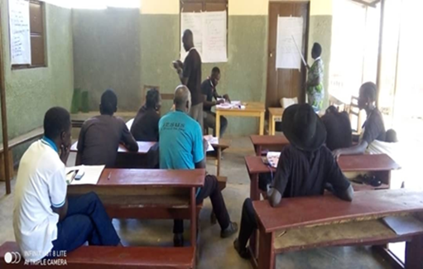 | 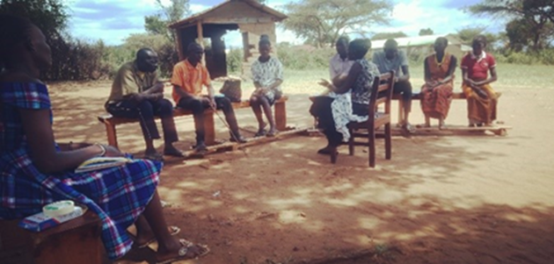
Agiamondo Project: JPC training in Kapedo (20/03/2024) | Agiamondo Project: ADR Training Kalapata July 2024
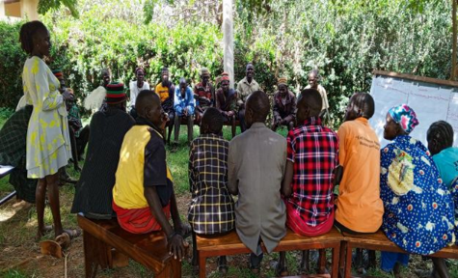 | 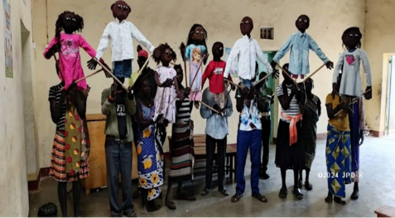
DKA Project: Traditional structures on debate 12/08/2024 | DKA Project: Champions holding puppets up after completing the construction. (2/12/2024)
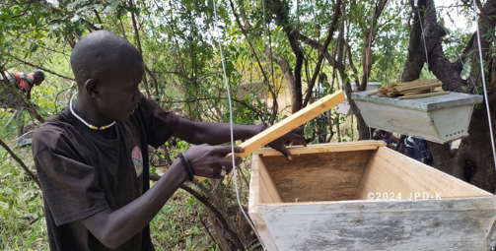 | 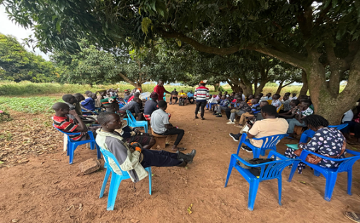
MOA Project: Apiary site set-up with demobilized youth in Rikitae. October 2024 | MOA Project: Cross-border peace dialogue in Orom (Acholi). November 2024
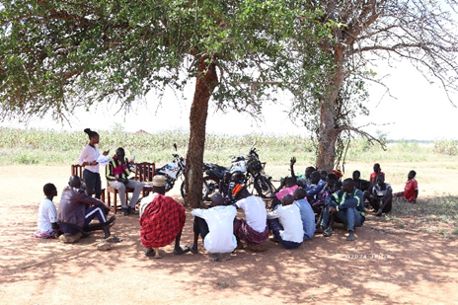 | 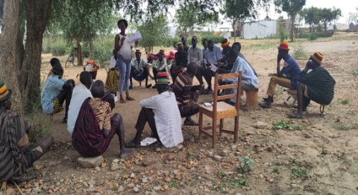
GIZ-CUSP Project: PEC members of Kaangorok parish during their PEC meeting on 13/11/2024 | GIZ-CUSP Project: LC1s of Kamoru sub-county during their verification meeting on the 11/10/2024

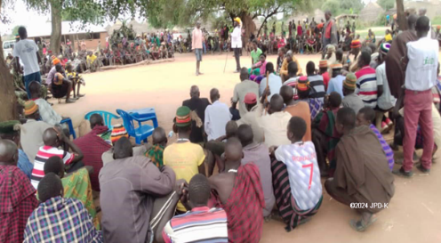 | 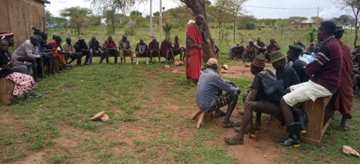
Diocesan funding: Dialogue in Kapeta in April 2024 | Diocesan funding: Dialogue in Kalapata, August 2024

Annex 2 Any important document relevant to the project
Monthly Report |  | Activity Reports
  ☐ | Yes | ☐ | No
  ☐ | Yes | ☐ | No
Budget Tracker |  | Other documents  (Specify:……………)
  ☐ | Yes | ☐ | No
  ☐ | Yes | ☐ | No

