Bi-ANNUAL REPORT
2025
Name of Funding Institution(s) | Agiamondo, DKA, Mondo Aperto Onlus, GIZ CUSP, CEI-SICSP, Zivik, Prosolidar
Reporting Period | 1st of January 2025 – 31st of December 2025
Type of Report | Annual Report
Name(s) and Function(s) of the Person(s) Responsible for the Report | Nicola Carradori (Coordinator)
Date of Submission | 28/04/2026

Table of Contents
1. Introduction/Summary 3
1.1. Target Groups reached 4
2. Changes in the Project Context 5
2.1. Changes in the organization 6
3. Report on the implementation of the project 7
3.1. Brief description of the M&E system and who was involved in preparing the report 7
3.2. Activities implemented to achieve the results 7
3.3. Success stories 36
4. Activities realized in other areas (max. 1.5 page) 38
4.1. Capacity Development and Knowledge Management 38
4.2. Networking and co-operation with relevant stakeholders 38
5. Lessons learned from implementation of Project (max 1 pages) 39
6. Challenges encountered and modifications (max 2 page) 40
6.1. Challenges faced in implementing the Project and possible solution 40
Annex 1 Photos 42

Introduction/Summary
This report covers the period between January 1st 2025 and June 30th 2025. It provides and overview of the operations of the Department across its various interventions. The Department has remained true to its Vision, Mission and Values:

Vision: A violence free society, where people live a just, peaceful and prosperous life.
Mission: To enable communities of Northern Karamoja to handle conflicts constructively, understand their rights and responsibilities and treat each other with respect.
Values: Social Justice, Human Dignity, Peace, Love and Inclusiveness.
The first half of 2025 has been proceeding smoothly. The Project implemented in 2024, and reported in the previous report, are continuing to be implemented without any major challenge. Three new Projects have been launched and started, supported by CEI-SICSP, Zivik and Prosolidar. As a result, the Department is now implementing 7 Projects.
Project title | Project Number | Donor | Focus | Geographical scope
Promoting Youth-Led Peacebuilding in North Karamoja | 2009 | Agiamondo | Intra- and inter-communal peacebuilding | Kotido, Kaabong, Abim, Karenga
Influencing Women land Rights in Kotido District | 158.016-D22/00128VT | DKA Austria | Women land rights and customary tenure security | Kotido
Towards Integrated Demobilization, Reintegration and Reconciliation in North Karamoja | 520/2024 | Mondo Aperto Onlus | Demobilisation, reintegration and reconciliation | Kotido, Kaabong, Abim, Karenga, Acholi and Turkana
Enhancing Environmental Governance through Disaster and Environment Structures in Kotido District | 20.2115 2 – 006.04 | GIZ CUSP | Environmental governance | Kotido
Holistic Reintegration of Demobilised Youth Combatants in North Karamoja | 156/2024 | CEI – SICSP | Demobilisation, reintegration and reconciliation | Kotido, Kaabong
Enhancing Demobilization, Reintegration and Reconciliation Efforts in North Karamoja | KP-014/25 | Zivik | Demobilisation, reintegration and reconciliation | Kotido, Kaabong, Abim, Karenga, Acholi
A Tractor to Enhance the Peace Consolidation Process through Socioeconomic Reintegration of Demobilized Youth Combatants in North Karamoja, Uganda | 733 | Prosolidar | Agriculture | Kotido

Target Groups reached
State the total numbers of target groups reached during this reporting period for direct beneficiaries. For continuing projects i.e., projects running for more than one year, please sum up the total on a yearly just as it is in the table below.
Project | DIRECT BENEFICIARIES
Project | Total Direct | Female |  |  | Male
Agiamondo | 2,526 | 338 |  |  | 2,188
DKA | 7,224 | 3,681 |  |  | 3,543
Mondo Aperto | 3,629 | 350 |  |  | 3,279
GIZ CUSP | 2,785 | 1,214 |  |  | 1,571
CEI | 2,766 | 75 |  |  | 2,691
Zivik | 12,570 | 4,040 |  |  | 8,530
Prosolidar | The tractor was utilized to support groups under Mondo Aperto and Agiamondo Projects
Total | 31,500 |  | 9,698 | 21,802

Changes in the Project Context
Please briefly describe relevant changes in the local / regional / national context that have and might influence the project (for example political, judicial, social, economic, ecological developments).
During the 2025 reporting period, several developments at the local, regional, and national levels significantly influenced the implementation and outcomes of the MOA–TIDRR project. These changes presented both challenges and opportunities for advancing peacebuilding and reintegration efforts in northern Karamoja.
Social and Security Context - The security situation in parts of northern Karamoja, particularly western Kotido and eastern Kaabong, deteriorated during the year, marked by rising incidents of killings, armed robberies, sexual violence, theft, and other criminal activities. This was specifically, but not exclusively, concentrated in western Kotido and Eastern Kaabong. These insecurity trends heightened fear among communities, disrupted livelihoods, and occasionally constrained the movement of project participants and staff. Concerted efforts by government and non-government actors led to subsided insecurity dynamics. At the same time, positive social transformation was observed in several dialogue locations, with Karachunas increasingly acknowledging past wrongdoings and expressing willingness to disengage from violence. Communities demonstrated growing openness to reconciliation, particularly where sustained dialogues had been conducted. Youth-led peace initiatives continued to reshape community dynamics, with young people assuming more visible leadership roles in mediation, advocacy, and local peace committees.
Security dynamics – During 2025, the security situation has remained mixed. Although levels of insecurity have remained relatively low in comparison to previous years, pockets of insecurity resurfaced cyclically, also influenced by election dynamics. Particularly in the areas of western Kotido and eastern Kaabong recurring incidents of armed robbery, livestock theft, and killings persisted. These volatile dynamics created uncertainty within communities and directly affected some beneficiaries, some of whom became victims of road ambushes and cattle theft. At the same time, inter-communal relations have sensibly improved. For instance, relations have improved between the Jie and Dodoth, which facilitated livestock trade, shared grazing arrangements, and access to watering points, particularly in border areas between Kaabong and Kotido. In addition, shared grazing and resource-use arrangements were increasingly reported among the Jie, Turkana, Matheniko, and Bokora communities in areas such as Kobebe, Nangolol Apolon, Sinyu, Toror Hill, and surrounding locations. Relations with the Acholi communities also improved following sustained dialogues, resulting in reduced atrocities, expanded discussions on free movement, shared resources, and the potential establishment of joint markets and economic exchanges.
Donor withdraws and sectoral challenges – In 2025 a variety of donors have cut and/or decreased their development cooperation funding for Uganda. This funding crisis has impacted the ability of non-governmental organizations to address contextual needs, including pressing and quickly evolving security dynamics. Indeed, many organizations have been forced to withdraw or scale down their activities. Whilst this has not directly impacted the funding of JPD-K, it has placed an increasing burden over the organization. Indeed, only a handful of actors have remained active in the operations focusing on conflict transformation and post-conflict stabilization. These actors are having challenges to respond to emerging crisis in light of the vastness of the area to be covered and the earmarked nature of Project funding. This has created a vacuum in conflict prone localities, especially where government reach is the feeblest (e.g. Kotido and Kaabong West).
Ecological and Environmental Context - Environmental pressures continued to undermine community resilience and aspects of project implementation. The construction of security roads around Kobebe significantly interfered with natural water flow into Kobebe Dam, causing it to nearly dry up and triggering the movement of livestock to distant areas such as Napak, Abim, Acholi, and Teso in search of water and pasture, thereby increasing pressure on cross-border relations. In addition, persistent human–wildlife conflict, particularly the destruction of gardens by elephants in parts of Kotido and Kaabong Districts, negatively affected food security and agricultural activities promoted under the project. Climate variability, marked by unpredictable rainfall patterns and prolonged dry spells, further reduced agricultural productivity and reinforced the need for adaptive livelihood strategies and diversified income sources.
Political and Administrative Context - The reporting period coincided with the gradual transition into a pre-election environment ahead of the 2026 general elections, which increasingly shaped local political dynamics. Heightened political mobilization and early campaign activities by aspiring leaders were observed across Kotido and Kaabong Districts. In some instances, campaign activities disrupted community meetings and peace engagements, as participants were drawn into political gatherings or became cautious about attending activities perceived to be politically sensitive. The election period also contributed to heightened community tensions, as political propaganda, misinformation, and divisive rhetoric occasionally reinforced existing ethnic, clan, or territorial fault lines. These dynamics required the project to exercise increased caution to maintain neutrality and ensure that peace dialogues and reintegration activities were not politicized or misinterpreted. While political leaders continued to play an important role in mobilization and peace advocacy, the competitive political environment underscored the risk of peace messages being co-opted for political gain.
Overall Contextual Assessment
Overall, the reporting period was shaped by a combination of persistent insecurity, improving but fragile inter-communal relations, economic vulnerability, environmental pressures, and a shifting political environment.
Despite these constraints, the Department remained responsive and adaptive. Its integrated approach, combining psychosocial support, livelihood strengthening, and flexible delivery mechanisms, enabled continued progress toward reintegration objectives. The interventions contributed to stabilizing DYCs, strengthening community resilience, and supporting gradual peace consolidation in Northern Karamoja.

Changes in the organization
The year 2025 has been dynamic year in terms of Projects implemented, number of staff employed and organizational policies developed.
- Projects In 2025, Department has secured funding for 3 new Projects financed by Conferenza Episcopale Italiana (CEI-SICSP), Zivik-Ifa and Prosolidar. On one hand, the Project funded by CEI-SICSP will be implemented until 2028. On the other, the Project supported by Zivik-Ifa was a 1-year pilot which is currently under review. The support of Prosolidar, which financed the purchase of a new tractor and plough has greatly boosted the Departmental ability to provide support to the communities on the ground. Unluckily, since October 2025 the Project supported by the GIZ-CUSP was brought to a halt together with all Project financed by the institution at national level after the Ugandan Government’s decisions. There has been no communication from GIZ since.
- Staffing/HR The increase in Projects has facilitate the HR growth of the Department with a total of 28 full-time staff members. One intern is currently supporting the Department.
- Organizational Policies The Department has supported the revision of relevant organizational policies, such as the Safeguarding Policy as well as the Financial and Procurement Policies. All of them are currently active.
The Department is currently in talks with other entities to further expand its Project portfolio, namely Zivik and Missio.

Report on the implementation of the project

Brief description of the M&E system and who was involved in preparing the report
Please describe your M&E system or any monitoring tools that you are using in this project to track progress and the person(s) involved in using the systems/tool, frequency of usage. If baseline or endline have been conducted, please specify.
Each Project has its own M&E system that has been developed by the MEAL Officer in cooperation with the relevant Project Teams. The Coordinator supervises the M&E system. For the Zivik-funded Project an external MEAL Consultant has been engaged to carry out baseline and endline assessments to ensure objectivity and impartiality.

Activities implemented to achieve the results
Please briefly describe the activities that have been conducted in the past year. This MUST be done chronologically and according to the SO and Result of reference. Within an activity the following must be included: date, number of participants (demographic differentiation – gender) and brief overview of the ativity (brief means no more than 3/4 lines). See Example below
Project: Promoting Youth-led Peacebuilding in North Karamoja
Donor: Agiamondo
SO1. Res1. Intra and Inter-communal tensions within North Karamoja and with neighbouring communities.
A1: Intra-community dialogues among the Jie of Kotido District. | - Napumpum Airstrip Dialogue - The 1st intra-community peace dialogue under the Agiamondo-funded Project was held on the 07/11/2025 at Napumpum Airstrip, Kotido District, on 7/11/2025, with 118 participants (110M, 8F) from various communities including Napumpum, Riktae, Panyangara, Kamoru, Kotido, and Bokora from Napak.  - Maaru Dialogue - The 2nd dialogue took place in Meenyanga-Maaru on the 11/11/2025 brought together 213 participants (184M, 29F) from communities surrounding Rustom–Maaru. The meeting addressed rising road robberies, cattle theft, and general insecurity affecting traders, women, and households.  - Sinyu Dialogue - The 3rd dialogue was held in Sinyu, Lopeei, Napak District, on the 14/11/2025, with 205 participants (203M, 2F) attending. The meeting provided a platform for community members to openly discuss the causes of cattle theft, particularly in the Bokora kraals, and to explore effective management of kraals to prevent future incidents.  - Rikitae Dialogue - The 4th dialogue took place in Rikitae on the 21/11/2025 and was attended by 223 participants (206M, 17F) in response to a worrying upsurge in household robberies, granary break-ins, armed waylaying, and increased livestock theft involving both local youth and suspected external collaborators.  - Kanair Dialogue - The 5th youth-led peace dialogue was held on the 15/12/2025 at the Peace Celebration Venue in Kanair Sub-County. The meeting brought together representatives from the Turkana, Matheniko, Bokora, and Jie communities drawn from several neighbouring sub-counties. A total of 219 participants attended (201M, 18F).  - Kamoru Dialogue - The 6th dialogue among the Jie was held on the 20/12/2025 in Kamoru Sub-County, Kotido District, on 20th December 2025, bringing together elders, youth, women, former armed youth, and local leaders. The dialogue was attended by 204 participants (177M, 27F) and focused on the continued theft of livestock belonging to the Bokora and Turkana communities, rising incidents of robbery within villages and sub-counties, and growing suspicions of rearmament among some youth.
  Dialogue location | Participants
  Dialogue location | M | F | Total
  Napumpum | 110 | 8 | 118
  Maaru | 184 | 29 | 213
  Sinyu | 203 | 2 | 205
  Rikitae | 206 | 17 | 223
  Kanair | 201 | 18 | 219
  Kamoru | 177 | 27 | 204
  Total | 1,081 | 101 | 1,182
A2: Intra-community dialogues among the Dodoth of Kaabong District. | - Kotome Dialogue - The 1st youth-led dialogue was held on the 12/11/2025 in Kotome Centre, Lodiko Subcounty, bringing together 218 (165M, 53F) participants including Karachunas, community elders, women, government leaders, and security actors) from Lodiko, Lobongia, Lodwar, Kalapata, and Timu to address the worsening insecurity in Kaabong East.  - Lodwar Dialogue - The 2nd dialogue was conducted in Lodwar, Kaabong District, on the 20/11/2025, and was attended by 171 participants (164M, 7F). The session brought together the community members of Lodwar and representatives from neighboring areas to reflect on the rising insecurity, including robberies, break-ins of houses and shops, and the threat posed by armed elements.  - Kalapata Dialogue - The 3rd dialogue was held in Kalapata Parish, Kaabong District on the 13th December 2025 and brought together 153 participants (99M, 54F), including Karachunas, elders, women, youth, and local leaders, with active participation recorded despite limited attendance from some neighboring communities due to mobilization gaps.  - Sokodu Dialogue - The 4th youth-led intra-communal peace dialogue was held in Sokodu, Kaabong District, on 5 December 2025. The engagement brought together community members from Sokodu and neighboring areas, 171 participants (117M, 54F). Discussions focused on the security situation following the recent demobilization of Karachunas and the community’s perceptions of safety.
  Dialogue location | Participants
  Dialogue location | M | F | Total
  Kotome | 165 | 53 | 218
  Lodwar | 164 | 7 | 171
  Kalapata | 99 | 54 | 153
  Sokodu | 117 | 54 | 171
  Total | 545 | 168 | 713
A4: Inter-community dialogues with the Acholi of Agago and Kitgum Districts. | - The Acholi–Karamoja Cross-Border Dialogues and Kamrono Peace Prayer took place from 20th to 22nd October 2025 in Adilang and Kamrono, Agago District. A total of 306 participants (237M and 69F) were officially registered and actively participated in the dialogue sessions.
A5: Inter-community dialogue with the Turkana. | - In January 2025 JPD-K facilitated a 3 days-long peacebuilding visit to the Turkana region. The MOA PO and a team of four Karachuna coordinators went to engage kraal leaders - Ikaleakwaan, Loumo, Merikou, and others in Loreng, Naturuturio and Nakitongo.
SO1.Res2: Recently disarmed youth are supported and reintegrated within their communities.
A3: Ex combatants are supported in their livelihoods | - Ploughing Program The initiative, which spanned from late March to mid-June 2025. A total of 13 groups were supported with Agiamondo funding and 134 acres ploughed.
A4: Coordination meetings among the Karachuna leaders of Kotido and Kaabong. | - On 25th February 2025, the Karachuna Coordination meeting was held, where two representatives from each sub-county attended for a total of 33 participants to present and discuss the security and peacebuilding situation.  - On 4th March 2025, a district security reflection dialogue was convened, bringing together 41 participants comprising Karachuna coordinators from across the district of Kotido, security stakeholders, and staff from the Justice and Peace Department–Kotido.
Project: Towards integrated Demobilization, Reintegration, and Reconciliation in Northern Karamoja
Donor: Mondo Aperto Onlus
SO1. Res1: Intra and inter-ethnic tensions and conflict within and among Jie and Dodoth counties are effectively prevented, managed and transformed through youth-led dialogue and advocacy.
A1: Youth-led dialogues were held at the community level among the Jie of Kotido District. | - Napeikar/Taabamuk Dialogue - The 1st dialogue was held on 23rd February 2025. Participants discussed livestock theft and violence involving Jie, Acholi, and Ethur communities, emphasizing Karachunas’ role in peacebuilding, youth reintegration, and accountability.  - Longaroi Dialogue - The 2nd dialogue was conducted on 16th March 2025. 114 participants (98M, 16F) examined revenge killings and illegal arms (39 guns reported). Leaders are committed to coordinated security efforts and curbing outsider influence.  - Natiir/Losakucha Dialogue - The 3rd dialogue took place on 18th March 2025. 168 participants (161M, 7F) discussed Acholi-targeted raids, illegal firearms, and outsider manipulation. Calls were made for disarmament and an inclusive Kokoria dialogue.  - Kalosarich/Sinyu Dialogue - The 4th dialogue was convened on 7th May 2025. 174 participants (173M, 1F) revisited child-killing resolutions, shared grazing/water strategies, and promoted cross-border peace with Turkana. Participation of Matheniko was low; firearm concerns were flagged.  - Panyangara Dialogue - The 5th dialogue was held on 13th June 2025. 335 participants (333M, 2F) assessed security, planned the annual peace prayer, and discussed cattle raids, thefts, corruption, and divisive labeling. Kanair was chosen for the peace prayer.  - Annual Peace Prayer - The 6th dialogue was marked by the Annual Peace Prayer held on 21st June 2025 in Kanair: 221 participants (183M, 38F) promoted reconciliation, forgiveness, and collective responsibility while honoring key peacebuilders.  - Lokwakial Dialogue - The 7th dialogue took place on 9th August 2025. 230 participants (205M, 25F) addressed crop, cattle, and property thefts. Offenders admitted actions; discussions strengthened accountability and cross-community collaboration.  - Lokitelaebu Dialogue - The 8th dialogue was conducted on 22nd August 2025. 323 participants (262M, 61F) discussed attacks, arbitrary arrests, and killings. Proposals included the release of unjustly arrested individuals and engagement with armed youth for disarmament.
  Dialogue location | Participants
  Dialogue location | M | F | Total
  Napeikar/Taabamuk | N/E | N/E | N/E
  Longaroi | 98 | 16 | 114
  Natiir/Losakucha | 161 | 07 | 168
  Kalosarich/Sinyu | 173 | 01 | 174
  Panyangara | 333 | 02 | 335
  Annual Peace Prayer | 183 | 38 | 221
  Lokwakial | 205 | 25 | 230
  Lokitelaebu | 262 | 61 | 323
  Total | 1,415 | 130 | 1,565
A2: Youth-led dialogues held at the community level among the Dodoth ethnic group of Kaabong/Karenga District. | - Morukori Dialogue - The 1st dialogue was conducted on the 25th November 2025 in Morukori. 226 participants (169M, 57F) addressed robberies, ambushes, break-ins, and killings. Commitments included reviving peace committees, supporting reintegration, and strengthening vigilance.  - Lotim Dialogue - The 2nd dialogue was held on the 28th November 2025 in Lotim. 121 participants (104M, 17F) discussed ambushes, robberies, rape cases, and cattle theft. Leaders emphasized full demobilization, parental involvement, and follow-up dialogue in Kalapata.
  Dialogue location | Participants
  Dialogue location | M | F | Total
  Morukori | 169 | 57 | 226
  Lotim | 104 | 17 | 121
  Total | 273 | 74 | 347
SO1.Res2: Increased awareness and skills in conflict transformation and dealing with the past of 12 groups of demobilized youth combatants (25 per group for a total of 300 individuals) in Kotido and Kaabong Districts.
A1: Training of 12 groups of demobilised youth combatants from Kotido and Kaabong Districts on conflict transformation. | - The 1st session of the CT Training was conducted between 21st July – 1st August 2025. 250 participants in 10 Karachuna groups trained on conflict drivers, resolution strategies, and peacebuilding. Improved group cohesion and VSLA/apiary commitments noted.  - The 2nd session of CT Training took place between the 18th–27th August 2025. 240 participants trained on mediation and communication skills, including livestock dispute simulations. Challenges included poor road access, absenteeism, and rising insecurity.  - The 3rd session of CT Training was held between the 13th–24th October 2025. 255 participants trained on gender-sensitive peacebuilding; eight groups received tranche 2 support for completed storage facilities.
  Training Session | Participants
  Training Session | M | F | Total
  Session 1 | 250 | 0 | 250
  Session 2 | 240 | 0 | 240
  Session 3 | 255 | 0 | 255
  Total | 745 | 0 | 745
A2: Training of 12 groups of demobilised youth combatants from Kotido and Kaabong Districts on dealing with the past. | - The 1st session of the DwP training was held between the 24th November and the 10th December 2025. 251 participants attended recap sessions assessing knowledge retention, practical application, and readiness for the next phase of project implementation.
SO1.Res3: Jie and Dodoth communities effectively dialogue and reconcile with neighbouring communities of Turkana, Acholi, Ethur and Ngiporein.
A2: Cross-border community dialogues held with the Turkana. | - The 1st engagement took place on the 20-21/02/2025 in Nakitongo & Naturiturio as an attemopt to reinforce resolutions and scheduling future dialogues.  - Kobebe Dialogue - The 2nd dialogue took place on March 8th 2025. A total of 450 (389M, 61F) participants from Turkana, Jie, Bokora, and Matheniko. Resolved to curb alcoholism, improve loan culture, and ensure community discipline.  - The 3rd engagement saw the Project Officer reaching Nalapatui and meeting 31 (27M, 4F) Turkana leaders for upcoming Dodoth dialogue coordination and security updates.  - Loyoro Dialogue - The 4th dialogue took place on the 14th–15th October 2025 in Loyoro. 323 participants (293M, 30F) reflected on shared peace efforts. Persistent tensions between Ngilukumong and Dodoth were addressed, with calls for truth-telling, joint visits, and youth-led collaboration.
  Dialogue location | Participants
  Dialogue location | M | F | Total
  Nakitongo | N/A | N/A | N/A
  Kobebe | 389 | 61 | 450
  Nalapatui | 27 | 4 | 31
  Loyoro | 293 | 30 | 323
  Total | 709 | 95 | 804
A3: Cross-border community dialogues held with the Acholi. | - Kapeta Dialogue - The 1st dialogue was held on the 5th September 2025 in Kokoria, Kapeta Parish. 118 participants (87M, 31F) discussed security, youth reintegration, and cross-border peacebuilding. Agreements included community-led initiatives and representative selection for joint Acholi-Karamoja meetings.  - Adilang Dialogue - The 2nd dialogue was held on the 17th September 2025 in Adilang. 71 participants (51M, 20F) reviewed security and peacebuilding progress. Proposed joint peace committees, women peace advocates, shared farms, markets, and culturally enriched future dialogues.
  Dialogue location | Participants
  Dialogue location | M | F | Total
  Kokoria | 87 | 31 | 118
  Kobebe | 51 | 20 | 71
  Total | 137 | 51 | 188
SO2. Res2: 12 cooperative groups of demobilized youth combatants are formed and able to develop and engage in sustainable agropastoral and agroforestry income-generating activities
A1: Purchase and provision of support in the form of seeds, including tree seedlings, and basic farming tools to each of the 12 groups. The support is going to be divided into 3 tranches. | - February 2025 – Tool Handle Support - Ten eligible groups received UGX 55,000 each for replacing tool handles. Lotim and Akuj Kitimoe were excluded for not meeting participation conditions.  - 1st–28th May 2025 – Seed Support (Tranche 1) - Ten groups received UGX 100,000 each for locally mobilized seeds. Lotim and Akuj Kitimoe missed out due to non-compliance. Though some complained about the low support, they were urged to take ownership. The assistance was well received, with groups committing to co-fund agricultural inputs.  - March–May 2025 – Garden Ploughing - 10 compliant Karachuna groups in Kotido and Kaabong had their gardens ploughed. Exclusions were due to weak participation and logistical issues. Acreage ploughed has significantly increased over the last year, showing a stronger commitment. Despite terrain and machinery challenges, activities progressed in areas like Lokolia and Nataaba Karum..
A2: Construction of Storage. | - Jan 31, 2025 – Store Completion Support: Groups showing commitment received cement, doors, and iron sheets. Only 10 groups out of 12 completed the construction.
A5: Creation of VSLA Group | - 10 groups established Village Savings and Loan Associations (VSLA). Received kits including savings boxes, ledgers, receipt books, pens, and stamps.
Project: Influencing women’s land rights in North Division, Losilang Parish, Kotido District
Donor: DKA Austria
SO1.Res1: Increased responsiveness of traditional structures in ensuring women participation on land-related issues the North Division, Losilang Parish of Kotido District.
A3: Conduct awareness raising sessions among communities at Parish level (6) and Village level (13). | - The 1st parish community awareness raising session was held on February 24th 2025, at Lochoto Parish. A total of 100 participants (48M and 52F).  - The 2nd parish awareness raising was held on February 27th 2025 at Nayese Parish and a total of 178 participants (62M and 116F).  - The 3rd parish community awareness raising was held on the 11th/03/2025, at Kotyang Parish, with 100 participants attending (48M and 52F), and 178 participants (62M and 116F) out of the expected 300 participants.  - The 4th parish community awareness raising was held on the 13th/03/2025, at Logwangaita Parish, with 178 participants (62M and 116F) out of the expected 150 participants.  - The 5th parish community awareness raising was held on the 15 /03/2025, at Miresiae Parish, with 148 participants (67M and 81 F) out of the expected 150 participants.  - The 6th parish community awareness raising was held on the 18 /03/2025, at Kapisnyang Parish, with attendance of 116 participants (58M and 58F) out of the expected 150 participants.  - The 7th village community awareness raising was held on the 20/03/2025, at Nariwo village, with attendance of 117 participants (43M and 74F) out of the expected 150 participants.  - The 8th village community awareness raising was held on the 22/03/2025, at Loonei and Lorengechorwa village, with attendance of 127 participants (40M and 87F) out of the expected 150 participants.  - The 9th village community awareness raising was held on the 09/04/2025, at Kotyang Parish in Lokwor and Kadakori with attendance of 92 participants (46M and 46F) out of expected 150.  - The 10th village community awareness raising was held on the 10/04/2025, at Naapong village with attendance of 128 participants (57M and 71F) out of the expected 150.  - The 11th village community awareness raise was held on the 11/04/2025, at Nariamatolim village with attendance of 125 participants (52M and 73F) out of the expected 150.  - The 12th village community awareness raising was held on the 12/04/2025, at Toroi, and Toroi Upe villages with attendance of 92 participants (46M and 46F) out of the expected 150. .  - The 13th village community awareness raising was held on the 13/04/2025, at Lodera 1 and 2 villages with attendance of 85 participants (40M and 45F) out of the expected 150.  - The 14th village community awareness raising was held on the 15/04/2025, at Poet, Nawii Napao, and Miresiae villages with attendance of 85 participants (40M and 45F) out of the expected 150.  - The 15th village community awareness raising was held on the 16/04/2025 at Lojomanginyangatom village with attendance of 139 participants (67M and 72F) out of the expected 150.  - The 16th village community awareness raising was held on the 17/04/2025 at Morueperu village with attendance of 70 participants (33M and 37F) out of the expected 150.  - The 17th village community awareness raising was held on the 13/05/2025 at Natedekitoe village with attendance of 139 participants (67M and 72F) out of the expected 150.  - The 18th village community awareness raising was held on the 14/05/2025 at Jimos village with attendance of 98 participants (51M and 47F) out of the expected 150.  - The 19th village community awareness raising was held on the 15/05/2025 at Moruongor village with attendance of 123 participants (67M and 66F) out of the expected 150.
  Session | M | F | T
  Awareness raising 1 | 48 | 52 | 100
  Awareness raising 2 | 62 | 116 | 178
  Awareness raising 3 | 48 | 52 | 100
  Awareness raising 4 | 62 | 116 | 178
  Awareness raising 5 | 67 | 81 | 148
  Awareness raising 6 | 58 | 58 | 116
  Awareness raising 7 | 43 | 74 | 117
  Awareness raising 8 | 40 | 87 | 127
  Awareness raising 9 | 46 | 46 | 92
  Awareness raising 10 | 57 | 71 | 128
  Awareness raising 11 | 52 | 73 | 125
  Awareness raising 12 | 46 | 46 | 92
  Awareness raising 13 | 40 | 45 | 85
  Awareness raising 14 | 40 | 45 | 85
  Awareness raising 15 | 67 | 72 | 139
  Awareness raising 16 | 33 | 37 | 70
  Awareness raising 17 | 67 | 72 | 139
  Awareness raising 18 | 51 | 47 | 98
  Awareness raising 19 | 67 | 66 | 123
  Total | 994 | 1,256 | 2,250
SO1.Res2: More effective local advocacy on gender-sensitive land rights, conflict resolution and mediation and non-discrimination of women (especially against land access, management, control and ownership).
A1: Four (4) Advocacy training sessions for selected beneficiaries identified as role models/champions (40) of both SO1. Res.1 and SO2. | - The 2nd session of advocacy training for champions, consisting of two groups, took place on January 20/1/2025, at Losilang Parish Hall. A total of 37 participants attended (27M and 10F).
A2: Six (6) Advocacy meetings for beneficiaries trained under SO1. Res.2 Activity 1. | - The 1st reflection meeting on advocacy by the champions (comprising two groups) occurred in January 21st 2025 at Losilang Parish Hall. 41 participants (31M and 10F) attended.  - The 2nd reflection meeting on advocacy topic by the champions (comprising two groups) occurred in February 17th 2025 at Losilang Parish Hall. 40 participants (28M and 12F) attended.
  Session | M | F | T
  Session 1 | 31 | 10 | 41
  Session 2 | 28 | 12 | 40
  Total | 59 | 22 | 81
SO2.Res1: Improved awareness of 39 couples and 10 widows on gender-sensitive land rights, conflict resolution and management, non-discrimination of women (especially against land access, management, control and ownership).
A3: Thirty (30) elective coaching sessions for beneficiaries of O2. Res 1 on gender-sensitive land rights, conflict resolution and management, non-discrimination of women and other types of support. | - On 23rd January 2025, the 11th coaching session for the champions group was held, at Losilang Parish compound. A total of 32 participants (24M and 8F) attended.  - On 24th February 2025, the 12th coaching session for the champions, couples and widows was held on February 20, 2025, at the Losilang Parish compound. A total of 36 participants (27M and 9F) attended, and a total of 64 participants (37M and 27F) attended the session for the couples and widows.  - On the 25^{th of} March 2025, the 13th coaching session for the widows, couples and champions group were held at the Losilang Parish compound. A total of 53 participants (29M and 19F) attended.  - On the 24^{th of} April 2025, the 14th coaching session for the widows, couples and champions group were held at the Losilang Parish compound. A total of 53 participants (29M and 19F) attended.  - On the 27^{th of} May 2025, the 15th coaching session for the widows, couples and champions group were held at the Losilang Parish compound. A total of 46 participants (26M and 20F) attended.  - On the 27^{th of} June 2025, the 16th coaching session for the widows, couples and champions group were held at the Losilang Parish compound. A total of 58 participants (29M and 24F) attended.  - On the 29th of July 2025, the 17th coaching session for the widows, couples and champions group were held at the Losilang Parish compound. A total of 53 participants (29M and 24F) attended.  - On the 27th of August 2025, the 18th coaching session for the widows, couples and champions group were held at the Losilang Parish compound. A total of 89 participants (47M and 42F) attended.  - On the 30th of September 2025, the 19th coaching session for couples and widows, and the champion group was held at the Losilang parish compound. A total of 46 participants (24M and 22F) attended.  - On the 28^{th of} October 2025, the 20th coaching for couples and widows was held at the Losilang parish compound. A total of 110 participants (49M and 61F) attended.  - On the 28^{th of} November 2025, the 21st coaching for couples and widows was held at the Losilang parish compound. A total of 80 participants (39M and 41F) attended.  - On the 15^{th of} December 2025, the 22st coaching session for couples and widows was held at the Losilang parish compound. A total of 73 participants (33M and 40F) attended.
  Session | M | F | T
  Coaching session 11 | 24 | 8 | 32
  Coaching session 12 | 27 | 9 | 36
  Coaching session 13 | 29 | 19 | 48
  Coaching session 14 | 28 | 25 | 53
  Coaching session 15 | 26 | 20 | 46
  Coaching session 16 | 29 | 24 | 53
  Coaching session 17 | 29 | 24 | 53
  Coaching session 18 | 47 | 42 | 89
  Coaching session 19 | 24 | 22 | 46
  Coaching session 20 | 49 | 61 | 110
  Coaching session 21 | 39 | 41 | 80
  Coaching session 22 | 33 | 40 | 73
  Total | 384 | 335 | 719
SO2.Res3: Creation of a Communal Land Association whose constitution aligns with the provisions contained in the Land Act, especially with regard to women's rights and representation.
A1: Community awareness creation meetings on Land Rights and land protection measures. | - On May 20th 2025, the 1st community awareness creation meeting was held in Kapisnyang parish, and a total of 157 participants (77M and 80F).  - On May 21st 2025, the 2nd community creation meeting was held in Lochoto parish, and a total of 108 participants (50M and 58F).  - On May 22nd 2025, the 3rd community creation meeting was held in Nayese parish, and a total of 81 participants (46M and 35F).  - On June 19th 2025, the 4th creation meeting was held in Logwangaita parish, with attendance of 136 participants (40M and 96F).  - On June 20th 2025, the 5th awareness creation meeting was held in Kotyang parish, with attendance of 124 participants (42M and 82F).  - On June 26th 2025, the 6th awareness creation meeting was held in Miresiae parish, with attendance of 166 participants (82M and 84F).
  Session | M | F | T
  Community creation meeting 1 | 77 | 80 | 157
  Community creation meeting 2 | 50 | 58 | 108
  Community creation meeting 3 | 46 | 35 | 81
  Community creation meeting 4 | 40 | 96 | 136
  Community creation meeting 5 | 42 | 82 | 124
  Community creation meeting 6 | 82 | 84 | 166
  Total | 337 | 435 | 772
A2: Community information meetings on Communal Land Association as a mean to protect land. | - On August 19^{th,} 2025, the 1st community information meeting was held in Kotyang parish, and a total of 166 participants (117M and 49F) attended.  - On August 21^{st,} 2025, the 2nd community information meeting was held in Kapisnyang parish, and a total of 172 participants (94M and 78F) attended.  - On August 22^{nd,} 2025, the 3rd community information meeting was held in Miresiae parish, and a total of 184 participants (98M and 86F) attended.  - On August 26^{th,} 2025, the 4th community information meeting was held in Logwangaita parish, and a total of 106 participants (38M and 68F) attended.  - On September 23^{rd,} 2025, the 5th community information meeting was held in Lochoto parish, and a total of 211 participants (107M and 104F) attended.  - On September 25^{th,} 2025, the 6th community information meeting was held in Nayese parish, and a total of 222 participants (87M and 135F) attended.
  Session | M | F | T
  Community creation meeting 1 | 117 | 49 | 166
  Community creation meeting 2 | 94 | 78 | 172
  Community creation meeting 3 | 98 | 86 | 184
  Community creation meeting 4 | 38 | 68 | 106
  Community creation meeting 5 | 107 | 104 | 211
  Community creation meeting 6 | 87 | 135 | 222
  Total | 541 | 520 | 1,061
A3: Conduct 6 meetings at Civil Parish level with the election of Parish Committees who will represent the Parish at Division level, explaining roles and responsibilities. | - On October 14th,2025, the 1st meeting with the election of the parish committee was held in Kapisinyang Parish, and a total of 188 participants (105M and 83F) attended.  - On October 16th,2025, the 2nd meeting with the election of the parish committee was held in Miresiae, and a total of 205 participants (130M and 75F) attended.  - On October 21st,2025, the 3r^{d} meeting with the election of the parish committee was held in Kotyang, and a total of 257participants (178M and 79F) attended.  - On October 23rd,2025, the 4th meeting with the election of the parish committee was held in Logwangaita Parish, and a total of 249participants (115M and 134F) attended  - On November 11th ,2025, the 5th meeting with the election of the parish committee was held in Lochoto Parish, and a total of 173 participants (97M and 76F) attended.  - On November 12th ,2025, the 6th meeting with the election of the parish committee was held in Nayese Parish, and a total of 203 participants (96M and 107F) attended.
  Session | M | F | T
  Community creation meeting 1 | 105 | 83 | 188
  Community creation meeting 2 | 130 | 75 | 205
  Community creation meeting 3 | 178 | 79 | 257
  Community creation meeting 4 | 115 | 134 | 249
  Community creation meeting 5 | 97 | 76 | 173
  Community creation meeting 6 | 96 | 107 | 203
  Total | 721 | 554 | 1,275
A4: Identification of Community Volunteer who will conduct the registration/census of community members interested in becoming members of the CLA. | - On November 14th, 2025, the 1st meeting and identification of community volunteers was held in Kapisnyang Parish, and a total of 177 participants (77M and 100F) attended.  - On November 17th, 2025, the 2nd meeting and identification of community volunteers was held in Kotyang Parish, and a total of 203 participants (118M and 85F) attended.  - On November 18th, 2025, the 3rd meeting and identification of community volunteers was held in Miresiae Parish, and a total of 186 participants (102M and 84F) attended.  - On November 19th, 2025, the 4th meeting and identification of community volunteers was held in Logwangaita Parish, and a total of 170 participants (77M and 93F) attended.  - On November 20th, 2025, the 5th meeting and identification of community volunteers was held in Lochoto Parish, and a total of 153 participants (56M and 97F) attended.  - On November 21st, 2025, the 6th meeting and identification of community volunteers was held in Kapisnyang Parish, and a total of 177 participants (77M and 100F) attended.
  Session | M | F | T
  Identification of community volunteer 1 | 77 | 100 | 177
  Identification of community volunteer 2 | 118 | 85 | 203
  Identification of community volunteer 3 | 102 | 84 | 186
  Identification of community volunteer 4 | 77 | 93 | 170
  Identification of community volunteer 5 | 56 | 97 | 153
  Identification of community volunteer 6 | 77 | 100 | 177
  Total | 507 | 559 | 1,066
Project: Enhancing Environmental Governance Through District Disaster Management committee and Environmental Governance Structures in Kotido District.
Donor: GIZ-CUSP
SO1.Res1: More effective coordination between the district, sub-counties and parishes on environmental management in Kotido District.
A1: 3 DDRMC meetings supported in Kotido District | - On the 20th of March 2025, the 1st meeting of the District Disaster Management Committee was conducted and supported. 21 (17M and 4F) attended the meeting.  - On the 19 of May 2025, the 2nd District Disaster management Committee (DDRMC) was conducted and supported. 27 (20M and 7F) participants attended the meeting.  - On 28/8/2025, the 3rd DDRMC meeting was supported and conducted. Thirty, 30 (15M and 15F), participants attended the meeting.
A2: 6 DEC meetings supported in Kotido District. | - On 29/4/2025, the first District Environmental Committee meeting was conducted and supported. Thirteen, 13 (8M and 5F) participants attended the meeting.  - On 17 June 2025, the 2nd District Environmental Committee [meeting was supported and conducted. Seventeen, 17 (10M and 7F) participants attended the meeting.
A3: 1.1.3. Eight (8) SCEC meetings supported and organised (1 each 3 months per sub-county) | - On the 29th and 30th of January 2025, the first 2 SCEC meetings were conducted for two days in Rengen and Kamoru sub counties. Thirty-seven, 37 (25M and 12 F) attended the meetings.  - On 16th and 17th of April 2025, the 2 SCEC meetings were conducted in the sub counties of Regen and Kamoru respectively. Eighteen, 18 participants (11M and 8F), and seventeen 17 participants (11M and 6F) in Rengen and Kamoru sub counties respectively.  - On 20th and 21st of August 2025, the 2 SCEC meetings were conducted in Regen and Kamoru sub counties. Thirty-six, 36 (22M and 14F), out of the expected 30 participants attended the meetings.  - On 16-17/9/2025, the last session of the Sub county Environmental Committee (SCEC) meetings were conducted. Thirty-six, 36 (20M and 16F) participated in the event, out of the expected 30 participants.
A4: Thirty-eight (38) PEC meetings supported and organised | - On the 18th to 28th of March 2025, 8 PEC meetings were conducted in the two sub counties of Regen and Kamoru targeting all the eight civil parishes. 163 (89M and 74F) attended the PEC meetings.  - On the 22-30th of April 2025, 8 PEC meetings were conducted in the parishes of Kamoru and Regen sub counties respectively. 158 (82M and 76F) participants attended the event.
A5: Exchange visit of district officials to Nebbi District to explore the modus operandi of a district with effective environmental governance targeting 4 members of Natural Resource Department. | - On the 31/8/2025-4/9/2025, The Exchange visit of the district officials to Nebbi was conducted. Twelve participants, 12 (9M and 3F) participated in the leaning exchange visit. This attendance is inclusive of the Nebbi district staff.
A6: Organise 3 trainings for 12 participants; Natural Resources Department staff (6) and JPD-K staff (6) on sustainable environmental management, alternative livelihoods, advocacy and community facilitation. | - On the 25th-27th/11/2024, the first training of the Natural Resource Department staff and the Justice and Peace Department staff was conducted. The training took place in the diocesan boardroom in attendance was 14 (9M and 5F).  - On 30,31/7/2025-1/8/2025, the second training of the Natural Resource department and the Justice and Peace Department was conducted. The training was conducted in Toto Maria Hall of Kotido Catholic Diocese, in attendance were twelve, 12 (5M and 7F).
Res 2: Improved awareness on environmental policies, sustainable environmental management, and alternative livelihoods of the communities of Regen and Kamoru sub-counties, Kotido District.
A1: Conduct 24 Environmental Information Clinics – EIC. | - From the 19-30 of May 2025, 8 community dialogues to introduction to Environmental Information Clinics (EICs) were conducted in the parishes of Rengen and Kamoru respectively. Nine hundred seventy-one, 971 (582M and 389F) participants attended the event.  - On 25th-27th of August 2025, 3 EICs were conducted in the parishes of Kamoru Sub County respectively. 429 (225M and 204F) participated in the event.  - On the 23-30/92025, The Environmental Information Clinics (EICs), were conducted in the parishes of Rengen sub county. Five hundred eight, 503 (280M and 228F) participated in the events.
A2 : Training of 20 women PEC members on energy saving technologies (Briquette making and Lorena energy saving stoves). | - One the 18-10/9/2025, The training of 20 women PEC members on Lorena Energy saving stove and Briquettes making was conducted. Twenty-three, 23 (01M and 22F) attended the event, out of the 20 expected participants.
So1.Res3: Creation of 2 SCECs and 8 PECs in Rengen and Kamor sub-counties, Kotido District.
A1: Organise 4 meetings (2 per sub-county) targeting 65 LC1s per meeting to convey the information about the formation of SCEC and PECs and EIC and ask for the identification of potential representatives from each village. | - On the 04th/ 5th/ 10/ 2024, the 1st meeting with the LC1s of Rengen and Kamoru sub counties was conducted. The total number of participants in attendance was 64 (63M and 01F) out of the 72 expected participants.  - On the 11th/12th/10/2024, the 2nd meeting with LC1s was conducted. Fifty-two, 52 (51M, 01F), participants attended the event out of the expected 72.
A3: Organise 3 trainings for 138 PEC and SCEC members on sustainable environmental management, forest management, alternative livelihoods effects of climate change, and advocacy. | - On the 24-28/2/2025, the first training of the PECs and SCECs on sustainable environmental management and climate change adaptation and mitigation was conducted. The total number of participants was 155 (87M and 68F).  - On the 16-30/9/2025, the second session of the training of the PECs and SCECs was conducted in the parishes of Kamoru and Rengen respectively, One hundred fifty eight, 158(68M and 86F) participated in the event out of the 150 expected participants.
Project: Holistic Reintegration of Demobilised Youth Combatants in North Karamoja
Donor: CEI-SICSP
SO1.Res1: 293 demobilised youth combatants develop and increase their specific knowledge, skills and competencies in the agropastoral or other relevant sector through TVET programs.
A1: In-depth study on alternative livelihoods and income generating activities viable in the sub-region will be conducted. | - The market assessment was conducted between the 12th and 22nd of November 2025 through the Districts of Kotido, Kaabong, Lira and Soroti. A total of 147 individuals were sampled as respondents for the exercise. The study, which utilized a mixed-method approach informed the selection of skilling and livelihood pathways for DYCSs.
A2: Identification of 293 demobilised youth combatants of their skilling preferences in cooperation with the security authorities and the local administration. | - The 1st phase identification process of DYCs took place between the 14-26/05/2025. The activity generally proceeded well with high levels of interest within the youth and broader community members.  - The 2nd phase of the identification process proceeded in Kaabong up to the 14/07/2025. A total of 2,467 individuals (M2,392 F75) attended the 1st and 2nd phases of activity.  - The 3rd and final phase of the identification process took place between the 28-31/10/2025. Four (4) individuals were replaced in Kaabong District because they did not meet required parameters.
A3: Support to the two TVET centres in Kotido and Kaabong in staff formation (6 total) and provision of relevant teaching material and inputs for the effective training of demobilised youth. | - The assessment of TVET centers took place from the 23-25/04/2025. The centers assessed were (1) Toto Maria Vocation Centre in Kotido on the (2) Kaabong Technical Institute, and (3) Kotido Technical Institute. The assessment provided an overview of the of the general state of the Centers and of their needs.  - In the month of September 2025 6 livelihood field assistants and the Project Officer (Livelihoods) were trained in regenerative agriculture, animal health and disaster risk reduction at the ADRAA Franciscan Center in Madi Okollo.
A9: Training of 293 demobilised youth in basic literacy and numeracy. | - The identification of local teachers for literacy and numeracy training started on 23/10/2025 in Kotido and concluded in Kaabong which on 3/12/2025.
SO1.Res2: 293 demobilised youth combatants are able to develop and engage in sustainable income generating activities in line with the TVET program of their choice.
A3: Creation of interparish VSLA among targeted demobilised youth. | - The training of Livelihood Field Assistants on the Village Savings and Loan Association (VSLA) approach was successfully conducted in a period of two (2) days from 27th to 28th November 2025 at the Kotido Diocesan Board room. A total of 7 individuals took part in the activity.  - The introduction of interparish VSLA groups among the demobilized youth took place between the 08-18th/12/2025. A total of 237 DYCs participated in the training sessions.
SO2. Res1: Improved psychological wellbeing of 293 demobilised youth combatants.
A1: In-depth assessment of the mental health capacities of local health care institutions in Kotido and Kaabong. | - The in-depth assessment of health institutions in Kaabong and Kotido took place between the 16th and the 25th of April 2025. A total of 35 structures were assessed, with 22 assessed in Kaabong and 13 in Kotido. The findings highlighted that while some facilities offer basic counseling services, most of them lack trained staff, supervision, private space, proper referral systems and regular data collection. Only a few had psychotropic drugs in stock.
A2: Capacity building of 10 Psychosocial Support Assistants in peripheral areas. | - The training of 9 PSAs (M 4, F5), on Problem Management Plus (PM+) was held in Kotido district from 18-23/08/2025 at the formation Center Giuseppe Filippi.
A3: Psychological screening of 293 demobilised youth combatants to identify potential psychosocial challenges hindering their wellbeing. | - The screening was conducted between October to November 2025 in Kotido and Kaabong, a total of 299 disarmed youth (Karachunas) was screened for psychosocial support needs and services.
A4: Identified individuals among the targeted 293 demobilised youth combatants undergo periodical individual therapy sessions. | - The 1st session of Interpersonal Psychotherapy (IPT) for the demobilized youth combatants (DYC) was conducted in Kaabong and Kotido Districts from between November and December 2025, a total of 299 Karachunas participated in the sessions - Kotido (152) and Kaabong (147).
Project: Enhancing the Efforts towards Demobilization, Reintegration and Reconciliation in North Karamoja
Donor: Zivik
SO1.Res1: Intra and inter-ethnic tensions and conflict within and among Jie and Dodoth counties are effectively prevented, managed and transformed through youth-led dialogue and advocacy.
A1: Five (5) Youth-led dialogues were held at the community level among the Jie of Kotido District. | - Napeikar Dialogue - The 1st peace dialogue which was held in Napeikar on 24/04/2025 convened the total of 289 (216M and 71F) members with the aim of addressing the recurring insecurity issues.  - Potongor Dialogue - On the 21/06/2025, the 2nd peace prayer which was held at Potongor village in Kotido district attracted 756 (539M, 217F) participants. This was aimed at addressing the cross-border issues existing between the Karamojong and the Turkana.  - Kanalobae Dialogue - On 26th June 2025, the 3rd youth-led peace dialogue that was convened in Kanalobae Parish, Maaru Sub-County, Kotido District, bringing together 272 participants (187M, 85F), discussing on the matters of peace consolidation.  - Lokitelaebu Dialogue - On the 15th August 2025, the 4th dialogue was held in Lokitelaebu Ward, Kotido District, which convened 269 (191M, 78F). The dialogue created a space for frank discussions on insecurity, including targeted killings, proliferation of illegal firearms, and the role of outsiders in fueling violence.  - Nakoreto Dialogue - On 09/09/2025, the 5th youth-led peace dialogue was held at the Catholic Chapel in Nakoreto convened a total of 155 (124M, 31F) participants discussing on how security isolated security incidences should be mitigated.
  Dialogue location | Participants
  Dialogue location | M | F | Total
  Napeikar | 216 | 71 | 289
  Potongor | 539 | 217 | 756
  Kanalobae | 187 | 85 | 272
  Lokitelaebu | 191 | 78 | 269
  Nakoreto | 124 | 31 | 155
  Total | 1,257 | 482 | 1,739
A2: five (5) Youth-led dialogues held at the community level among the Dodoth ethnic group of Kaabong/Karenga District. | - Kalapata Dialogue - On 25th March 2025, the 1st peace dialogue was held in Kalapata, Kaabong East, engaging 126 participants (109M, 17F), including Karachunas, elders, local leaders, and youth from surrounding parishes.  - Lowakuj Dialogue - On 27th June 2025, a peace dialogue was held at in Lowakuj, Sangar Sub-County, Karenga District, to address tensions among the communities of Sagar, Kalotwo, and Lowakuj. This was attended by 161 (109M, 52F).  - Kakamar Dialogue - On 30th July 2025, a youth-led peace dialogue was convened in Kakamar Parish, Kaabong West, Kaabong District, bringing together 268 (236M, 32F) participants. The meeting focused identifying factors for continued raids, exploring the local and CIMIC solution mitigating these occurrences.  - Lodwar Dialogue - Another dialogue was Lodwar on the 26th/09/2025 which convened the total of 194 (181M, 13F). The rationale of the meeting was to discuss on the factors underlying the worsening Civil Military relationship and the possible measures to improve it.  - Kotome Dialogue - The peace dialogue that took place in Kotome parish on the 24th/10/2025 convened the total of 204 (174M, 30F) people across kaabong districts in the sub counties of Kaabong.
  Dialogue location | Participants
  Dialogue location | M | F | Total
  Kalapata | 109 | 17 | 126
  Lokwakuj | 109 | 52 | 161
  Kakamar | 236 | 32 | 268
  Lodwar | 181 | 13 | 191
  Kotome | 174 | 30 | 204
  Total | 809 | 144 | 953
A3: (3) youth-led dialogues among the Jie and Dodoth are held in border areas of the two Districts (Kotido and Kaabong). | - Lochom Dialogue - On the 02nd August 2025, a youth-led peace dialogue was held in Lochom Parish, Kaabong District, bringing together 315 (301M, 14F) participants.  - Muledo Dialogue - On the 27th August 2025, a youth-led peace dialogue was held in Muledo village, Lolelia Sub County at the border between Kotido and Kaabong. This meeting convened a total of 189 (140M, 49F) participants and particularly focused on investigating the criminals for the rampant rise of armed robbery in the area, seek for local solutions in curbing this vice.  - Kopoth Dialogue - This meeting was held in Kopoth, at the border between the Jie and the Dodoth on 02nd/10/2025, convening the total of 182 (149M, 33F) participants. Addressing the factors for the cattle influx back to the protected kraals in Kaabong.
  Dialogue location | Participants
  Dialogue location | M | F | Total
  Lochom | 301 | 14 | 315
  Muledo | 49 | 140 | 189
  Kopoth | 33 | 149 | 182
  Total | 383 | 303 | 686
A4: (8) Radio talk shows are conducted to sensitize communities on the importance of peace and development. | - On the 21/06/2025, the 1st and 2nd series of the radio talk shows were conducted in 92.7 Etoil a karamoja FM in Kotido with the grand aim of mobilizing the community for the Kanir peace prayers and passing the peace messages to the community across the Northern Karamoja and the neighbors.  - On the 14th/09/2025, the 3rd radio talk show was conducted in at Wang-ooh FM 93.3 in Patongo Town council convening the total of 5 male panelists, who spread the message on the relevance of peaceful co-existence with the neighbors targeted to reach to over 1200s people.  - On the 21st/9/2025, the 4th radio was held at radio PIIWA 96.5 FM, Kalongo Town Council in Adilang, convening 3 male panelists who disseminated the message on peace consolidation and the protection of the peace gains that the community, targeted to reach to the 1000s of people.  - On the 5th of October 2025, the 5th radio talk was conducted in radion WASH OOH FM 93.3, in Patongo Town Council, Adilang. This convened the total of 3 (2M, 1F) panelists. This talk show was aimed at disseminating the peace messages aimed at reconstructing the relationship between the Acholi and the Jie community.  - On the 10th/10/2025, the 6th radio talk show held at 92.7 Etoil a karamoja FM in Kotido, attracting 4 male youth participants from both Kotido and Kaabong, who sensitized the community on the need to always stay vigilant and expose those criminals.  - On the 15th/12/2025, the 7th radio talk was conducted on Radio Piwa FM 96.5, in Kalongo Town Council, Agago District. The talk show aimed to disseminate peace messages and reconstruct the relationship between the Acholi and Jie communities.  - On 17/12/2025, the 8th radio talk show was conducted on 92.7 Etoil a karamoja FM in Kotido attracting 3 (2M, 1F) panelists to address the deteriorating peace among the people of Dodoth, Jie, and the Turkana, and further to alert the communities of the looming incidents of cattle theft and multiple costly payments, not deemed necessary.
SO1.Res2: Increased awareness and skills in conflict transformation and dealing with the past of the DYCs in Kotido and Kaabong.
A 5 : Training of 6 groups of DYCs and their partners/wives from Kotido and Kaabong Districts on conflict transformation and dealing with the past. | - The 1st session of conflict transformation training took place from 18th to 26th June 2025, in both Kotido and Kaabong districts, attracting the total of 240 (120M, 120F) participants.  - The 2nd one took place between the 18th to 23rd of August, 2025, held in the different participants’ group locations and convened the total of 240 (120M, 120F) participants.  - The 3rd conflict transformation training was held in the different group locations from 29th/09/2025 to 3rd/10/2025. These trainings convened total of 183 participants (84F and 99 M), covering the aspect of mainstreaming the gender roles in the conflict transformation.
  Training Session | Participants
  Training Session | M | F | Total
  Session 1 | 120 | 120 | 240
  Session 2 | 120 | 120 | 240
  Session 3 | 99 | 84 | 183
  Total | 339 | 324 | 663
A 6 Training of 6 groups of DYCs and their partners/wives from Kotido and Kaabong Districts on dealing with the past. | - Training on Dealing with the Past (DwP) was conducted from 02–04/12/2025 and attracted a total of 195 participants (107M, 87F). The activity provided an opportunity to revisit and consolidate key lessons from earlier conflict transformation trainings while introducing core concepts of Dealing with the Past.
  Training Session | Participants
  Training Session | M | F | Total
  Session 1 | 250 | 0 | 250
  Session 2 | 240 | 0 | 240
  Total | 745 | 0 | 745
SO1.Res3: Jie and Dodoth communities effectively dialogue and reconcile with the neighbouring communities of Turkana, Acholi, Ethur, and Ngiporein
A7: Four (4) youth-led community dialogues held between the Jie and/or Dodoth and their neighbors within Kotido Catholic Diocese – (2) Abim and (2) Karenga. | - Lobalangit Dialogue - On June 6, 2025, JPD-K convened a peace dialogue in Lobalangit, Karenga District. This engaged Lobalangit council members, community leaders, women, youth, reformed Karachuna from Sangar, Kalotwo, Kotido, and Kaabong, the LC3 Chairperson, and the Officer-in-Charge (OC) Police, the dialogue attracted 217 (164M, 53F).  - Alerek Dialogue - This peace dialogue was held on June 17, 2025, in Alerek Town Council, in Abim District, and was attended by 207 (184M, 23F).  - Sangar Dialogue - On 3rd September 2025, a youth-led dialogue was organized in Sangar, Karenga District, bringing together communities from Lobalangit, Sangar, and Kalotwo to deliberate on insecurity concerns. At least an estimated 200 participants were mobilized for the meeting, and were prevented from attending the dialogue by the excessive rainfall, the poorly developed transport network, and the meeting was postponed to a future date.  - Chamkok Dialogue - On the 31st/10/2025, this took place in Chamkok Sub County, Abim District, and convened a total of 83 (83M, 0F) participants who discussed the issues regarding the state of co-existence between the Ethur and the Jie community.
  Dialogue location | Participants
  Dialogue location | M | F | Total
  Lobalangit | 164 | 53 | 217
  Alerek | 184 | 23 | 207
  Sangar | 00 | 00 | 00
  Chamkok | 83 | 00 | 83
  Total | 431 | 76 | 507
Activity 8: Three (3) cross-border community dialogues held between communities of Jie and Dodoth and the Turkana. | - Kaalale Dialogue - The peace dialogue was held on April 16, 2025, in Kaalale and brought together 177 participants (142M, 35F) from the Dodoth, Jie, and Turkana communities  - Kobebe Dialogue - This second peace dialogue was held in Kobebe, Moroto district, at the border between Uganda and Kenya on the 30th of August, 2025. The meeting convened a total of 236 (226M, 12F) participants.  - Loyoro Dialogue - The cross-border peace dialogue, which was held in Loyoro on the 30th/09/2025, with a total of 234 (192M, 42F) participants. The meeting proceeded with bitter discussions due to the refusal of the Turkana to turn up for the meeting, and the LCV chairperson of Kaabong adjourned the meeting by fixing the next meeting to happen on the 07th/10/2025.
  Dialogue location | Participants
  Dialogue location | M | F | Total
  Kaalale | 142 | 55 | 177
  Kobebe | 226 | 12 | 238
  Loyoro | 192 | 42 | 234
  Total | 560 | 109 | 669
Activity 9: Three (3) cross-border community dialogues held between communities Jie and Dodoth and the Acholi. | - Losakucha Dialogue - On 1st April 2025, JPD-K convened a cross-border peace dialogue in Losakucha Parish, Kapeta Sub County, drawing 224 (57F, 167M) participants from the Jie and Acholi communities.  - Adilang Dialogue - The peace dialogue held at Adilang Sub-County brought together 169 participants (153M, 16F) from the Acholi and Karimojong communities to review security dynamics, address recurring tensions, and strengthen cross-community collaboration.  - Kokoria Dialogue - The cross-border peace dialogue between the Acholi and Karimojong communities was held on 27/11/2025 in Kokoria Parish, Kotido District, bringing together 200 participants (172M, 28F). The dialogue focused on past tensions, recent incidents of cattle raids, armed robberies, and the challenges posed by external criminal networks.
  Dialogue location | Participants
  Dialogue location | M | F | Total
  Losakucha | 167 | 57 | 224
  Adilang | 153 | 16 | 169
  Kokoria | 127 | 28 | 155
  Total | 447 | 101 | 548
Activity 10: Facilitate the attendance of the demobilized youth at the Dialogues of the Karamoja Cultural Festival. | - The 10th Karamoja Cultural Event (KCE), which was convened in Nakapiripirit from the 8th-13th-09/2025, gathered over 10,000 people across the Ateker cluster. These participants were the Karamojong, Teso, and Acholi of Uganda, Toposa of the South Sudan, Turkana of Western Kenya, and Nyangatom of Ethiopia. The event provided a platform for the maleficiated views with the theme of “strengthening Cultural Cohesion in Diversity for Socio-Economic Transformation.” During the participation in the event, the JPD-K facilitated the attendance of 422 (M355, F87) youths across Kotido and Kaabong.
  Location | Male | Female | Total
  Nakapiripirit | 355 | 87 | 422
  Grand Total | 355 | 87 | 422
SO2.Res1: Six (6) groups of the Demobilized Youth Combatants develop and increase their specific knowledge, skills, and competences in the apiary sector, based on basic Literacy and Numeracy.
Activity 11: Training of 6 groups of DYCs and their partners in basic literacy, numeracy, and business management. | - The preliminary session took place on 20th/06/2025 in the Kotido Diocese Board Room. It convened the 6 teachers selected to impart literacy and numeracy lessons to the group.  - The introductory session of the classes was held for all 6 groups of disarmed youth targeted between 23/06 and 30/06. A total of 217 participants attended (118M and 99F). Teachers were introduced to the groups, and teaching hours were chosen.  - Session 1 of the Literacy and Numeracy Training (LNT) was held in the month of June 2025. 201 (120M, 81M) participants took part in the training..  - Session 2 was held in the month of July 2025. It was attended by 153 (63M, 90F) participants in different locations.  - The sessions 3,4,5,6,7,8 were taught by the instructors between 5th and 31st of July 2025. These sessions aimed at training 240 (120M, 120F) participants across the locations.  - Sessions 9, 10, 11, 12, 13,14,15 and 16 continued between August 2 and September 2, 2025. A total of 240 participants took part in residential sessions held within their local communities.  - LNT Sessions 17 to 22 took place between September 3 and October 8, 2025. They convened a total of 240 (120M, 120F).  - Sessions 23 to 27 were held between 9th of October to the 02 of November, 2025. The exercise convened the total of 240 (120m, 120F) members.  - The mop up of sessions 23-27 were held in November 2025. A total of 306 members participated (176 M and 130F).
  Sessions | Male | Female | Total
  Preliminary | 06 | 00 | 6
  Introductory | 118 | 99 | 217
  S1-4 | 120 | 81 | 201
  S5-8 | 63 | 90 | 153
  S9-16 | 120 | 120 | 240
  S17-22 | 120 | 120 | 240
  S23-27 Oct | 120 | 120 | 240
  S23-27 Nov | 176 | 130 | 306
  Total | 843 | 760 | 1,603
Activity 12: Training of 4 members of each group (6 groups in total) in apiary and set-up of apiary farms in the chosen group sites | - The Apiary Training and on-site farm setup activity was held from April 14th to April 30th, 2025, in the Losilang Parish recreation Centre, and was attended by 168 participants(75F, 93M).
SO2.Res2: Six (6) Cooperative groups of the Demobilized Youth Combatants are formed and able to develop and engage in sustainable agropastoral and agroforestry income-generating activities.
Activity 13: Training for Project Officer and Project Assistant in regenerative agriculture. | - This activity took place on 16/3/2025 – 28/3/2025 at Palabek refugee settlement in Lamwo District. It was attended by the Project Officer and Project Assistant.
Activity 14: Training of 6 groups in regenerative agriculture through APFS Methodology. | - The Sessions 1 and 2 of Regenerative Agriculture took place on the 29-31 of May 2025. The training attracted 240 people (120M, 120F).  - Sessions 3 and 4 were held from 12th to 14th June 2025. Each group participated in two learning sessions, with a total of 240 (120M, 120F) in each session.  - The RD Training Sessions 5 and 6 took place from the 3rd of July to the 7th July 2025. Each group participated in two sessions, attracting 240 (120M, 120F).  - RD Training Sessions 7 and 8 took place from 8th to 10th June 2025. Each group participated in two sessions focusing on Practical approaches - Hydrological stabilization and surveying the contours. These trainings convened a total of 240 (120M, 120F) Participants.  - Sessions 9, 10 and 11 continued from 25th to 30th July 2025, implemented in Kotido and Kaabong. Each group participated in two practical sessions of Perma gardening phase 1 and 2 and the planting session. The activity targeted a total of 240 (120M, 120F) members, but attracted a total of 632 (363M, 269F) across the 3 sessions.  - Sessions 12 and 13 of RD training, which are practical sessions of making bio pesticides and designing of a block farm site using RD techniques, were held on 12th and 14th of August 2025. The session emphasized the making of biopesticides that can be used in the treatment of the crops in the block farm and further designing the block farm using the RD technique. This attracted 240 (120M, 120F) participants.  - Later, the session 14 and 15 of the RD training continued from 1st to 5th September 2025. Each of these groups participated in two practical sessions: Session 14 focused on core principles such as alley cropping, Farmer Managed Natural Regeneration (FMNR), agroforestry, and large-scale soil preparation, and Session 15 focused on involving slope analysis and strategic RD application on sloped terrain.  - The practical sessions 16 and 17 of the RD training continued from 22 to 24 September 2025, starting with Nakaabale Karachuna Peace Movement and climaxing with Kapelimen Reformed Warriors Group in Kaabong District, which involved a total of 192 (121M, 71F). These emphasized the application of the RD techniques in block farms, integrating seedbank development, food forest establishment, and Farmer-Managed Natural Regeneration (FMNR). Session 17 focused on constructing half-moon water harvesting structures and pruning indigenous tree species in the same block farm.  - Sessions 18 and 19 with the project groups in the districts of Kotido and Kaabong. This was geared at equipping the 199 (133M, 86F) participants with the knowledge and skills of integration of the livestock, poultry, and piggery within the same block farm to enhance productivity, ecological balance, and resource efficiency. Session 19 focused on the monitoring of RD systems to ensure a clear understanding of their long-term effectiveness and progress, equipping participants with skills and knowledge to track system performance.  - The project conducted Session 20 with the groups in Kotido and Kaabong Districts, targeting a total of 164 participants (95 males and 65 females). The session focused on equipping participants with the knowledge and skills to monitor RD systems, ensuring a clear understanding of the concept.
  Sessions | Male | Female | Total
  S1-2 | 120 | 120 | 240
  S 3-4 | 120 | 120 | 240
  S5-6 | 120 | 120 | 240
  S7-8 | 120 | 120 | 240
  S9-11 | 120 | 120 | 240
  S12-13 | 120 | 120 | 240
  S14-15 | 120 | 120 | 240
  S16-17 | 121 | 71 | 192
  S18-19 | 133 | 86 | 199
  S20 | 95 | 65 | 164
  Grand Total | 1,186 | 1,062 | 2,248
Activity 15: Provision of two tranches of logistical support seeds - including tree seedlings and basic farming tools - to each of the 6 groups of DYCs. | - The successful delivery of agricultural tools and seeds to the 6 demobilized youth combatants in Kaabong and Kotido districts was attended by a total of 195 participants with (117M and 78F).  - A total of 60 acres has been ploughed for the 6 groups between April and May 2025, the total of 240 (120M, 120F)  - Lastly, there was the successful delivery of the second tranche of agricultural tools and seeds to the Karachunas groups from the 16th-18th/10/2025 and this was attended by the total of 199 (113M, 86F) participants.
Activity 16: Development of 1 business plan and regulations for each of the groups | - Session 1 of the training on development of 1 business plan and regulations for each of the project groups was held from 21st to 23rd of October 2025, and convened a total of 172 (102M, 70F) participants. The training was a crucial step to build the capacity of the youth combatants to identify viable business opportunities, develop practical business plans, manage small-scale enterprises, and engage in VSLA for improved self-reliance and income generation.  - Session 2 on the development of one business plan and group regulations was held from 2nd–18th December 2025, engaging a total of 137 participants (84 males and 53 females). The training strengthened the capacity of youth combatants to manage finances by equipping them with key knowledge on record keeping, accountability, savings, investment, and financial action planning.
  Sessions | Male | Female | Total
  S1 | 102 | 70 | 172
  S2 | 84 | 53 | 137
  Grand Total | 186 | 123 | 309
Activity 17: Provision of necessary tools to engage in apiary for the trained individuals. | - All the tools were provided in April 2025 to a total of 240(120M, 120F) participants.
Activity 18: Creation of 1 VSLA for each of the 6 groups. | - The delivery of the VSLA boxes to the project groups was made on the 3rd to 6th of May, 2025, to a total of 240 (120M, 120F) participants.
Activity 19: Strengthening of the DYCs-led honey processing centre through the expansion of the structure and provision of one settling tank. | - The handover of apiary tools to the Karachuna Honey Processing Centre took place on 13th/05/2025 in Lokochil, Kotido. This marked a significant step in supporting sustainable beekeeping and honey production. This exercise was attended by a total of 40 (20M, 20F) karachunas from different locations.
Meal | - The baseline assessment that took place on the 14th to 24th/April/2025 was done by the consultant from the Centre for Basic Research.  - The mid-year monitoring took place on the 04th and 07th of November 2025 with the two Zivik project groups of Kotido and Kaabong. The exercise convened a total of 169 (M104 F65) participants. Notably, the joint monitoring was done by the district stakeholders and the department staff.  - On the 6th - 15th/12/2025, the end-line evaluation survey was carried out in the project intervention areas and extended to the satellite areas of intervention, attracting a total of 2 62 (140M, 122F) participants. The exercise progressed successfully to find out the impact of the project in Northern Karamoja and its neighborhood.
Project: A Tractor to Enhance the Peace Consolidation Process through Socioeconomic Reintegration of Demobilized Youth Combatants in North Karamoja, Uganda
Donor: Prosolidar
The tractor – McCormick MB85, plough and other servicing parts were purchased and delivered in June 2025.

Success stories
Write some success story from selected participants/groups. Follow these questions: 1) How was the situation before; 2) What has been done?; 3) What has changed since the intervention started. Be specific, include date of the interview, name of the interviewee, location.
The Projects have been implemented successfully across the board and the impact is being felt deep in the communities. Below are some examples of success stories.

MOA Project
- “This Life Is Sweeter Than the Bush” – Transformation of Ngikarachuna Ngulu ka Akicha Group (Interview: June 2, 2025)
The Ngikarachuna Ngulu ka Akicha group, once marginalized with no livestock for farming due to prolonged violence, has significantly improved thanks to MOA-TIDRR support. Following mechanized garden ploughing and other agricultural inputs, the group proudly harvested 10 bags of sorghum—an achievement they had not expected. Their newly established savings culture has empowered members to engage in livestock trade even across the border with Turkana. Group chairperson Akuruk Lomamngole expressed joy and commitment to peace, stating, “This life is sweeter than the bush—I would never go back. Through this support, I even own a cow today, and there's no more bloodshed, only peace.” The group now enjoys harmonious family relations, community acceptance, and positive ties with security forces, pledging to uphold reconciliation and nonviolence.
- “From Struggle to Symbol” – Arengechoto Youth Group Leading by Example
In Napumpum Sub-County, the Arengechoto Youth Group has emerged as a model of youth-led transformation and self-reliance in 2025. Despite limited external support, the group constructed a storage facility that generates steady rental income, fostering economic sustainability. Their fair distribution of last year’s harvest and plans for garden expansion this year reflect growing prosperity. The group is noted for their strong stance against violence and political interference, with members affirming, “Our only politician is the Church, because it has never lied to us since we began working together.” Their internal unity and savings culture have earned them respect and peaceful relations with neighboring Nyakwae and Bokora communities, setting a standard for reintegration and grassroots peacebuilding.

DKA Project
- Lometo Lonya’s testimony on equal distribution of land to his family.
On the 24th February 2025, Lometo Lonya the LC1 of Nayese parish Nadipal ward gave a testimony on how the community members mocked him when he gave plots to his children one to the girl and the other to the boy. In the past inheritance of the family assets were taken by boys and when he gave a plot to his daughter, the community members accused his wife and daughter for having bewitched him. They complained that the girl was to get married and her husband provides land for her. Lometo however remarked that he learnt the importance of giving land to both children without segregation. This he said has enhanced unity, respect and love in his family and he acknowledged that he learnt about it from the trainings that were held and now many other community members in Nayese are doing the same.
- Loyang Anna’s ability to access, control and manage the land given to her by her grand parents
On the 15th March 2025, Loyang Anna of Miresiae parish shared her experience on how she managed to fully access, control and own the plots that her parents left for her. She said she grew up from a family of 3 siblings and all being girls. In the past families with only girls were termed as doomed families where male relatives were brought in to inherit the family assets. Her parents on their demise gave her the authority to manage the assets and she fought a lot of obstacles from her relatives who tried to grab land from her. During the training, some of her relatives who tried to grab land from her where in attendance and they learnt that what they did was wrong and so on their return back home, they advocated for a challenge in the traditional norms that discriminated women. She concluded by saying she is now working towards documentation of her plots to avoid conflicts even in the future.

Activities realized in other areas (max. 1.5 page)

Capacity Development and Knowledge Management
Please describe any trainings you participated in during the reporting period and how the knowledge has been transferred internally within the rest of the team members and how it is aiding implementation.
A variety of trainings have been carried out for JPD-K team as a whole or for single staff members:
- The DKA Project Assistant (PA) attended Enhancing a safeguarding culture refresher training held at Nican Resort Hotel Kampala from the 28th to the 30th/04/2025 organized by DKA Austria.
- The Coordinator, Project Officer, and Project Assistant DKA, attended a training on Review of the National Land policies Sustainable Environmental Management at the parish hall Good shepherd Cathedral on 25th April 2025 organized by GIZ.
- The staffs attended an internal refresher training on Conflict transformation held in Kotido Diocese Board Room on 6th of May 2025, 9th and 23rd of June 2025 to train JPD-K staff on conflict transformation and peacebuilding approaches as well as the concept of Dealing with the Past.
- Between 18th–23rd August 2025, 9 Psychosocial Support Assistants (PSAs) under the CEI-funded Project were trained on Problem Management Plus (PM+), equipping them with practical skills to support individuals experiencing stress, anxiety, and emotional distress. This training laid the foundation for structured psychosocial support interventions under the project.
- In September 2025, 6 Livelihood Field Assistants and the Project Officer (Livelihoods) under the CEI-funded Project participated in a training on regenerative agriculture, animal health, and disaster risk reduction at the ADRAA Franciscan Center in Madi Okollo. The training strengthened the team’s capacity to promote climate-resilient and sustainable livelihood practices, which has since informed field-level guidance provided to beneficiary groups.
- From 27th–28th November 2025, 7 Livelihood Field Assistants under the CEI-funded Project were trained on the Village Savings and Loan Association (VSLA) methodology at the Kotido Diocesan Boardroom. The training focused on group formation, governance, savings mechanisms, and financial record-keeping, enabling staff to effectively guide VSLA implementation among beneficiary groups.

Networking and co-operation with relevant stakeholders
Please describe the networks and stakeholders that you are working with and what happened during this reporting period
During the reporting period, the Department maintained and strengthened collaboration with a wide range of stakeholders, which was critical for the successful implementation of reintegration, livelihood, and psychosocial support activities across Kotido and Kaabong Districts.
Key stakeholders included district and sub-county local governments, security agencies, health institutions, TVET centers, religious leaders, community structures and donors. Collaboration with these actors played a central role in facilitating beneficiary identification, activity implementation, and follow-up processes.
- Government and Security Structures: The Department worked closely with LC5 Chairpersons, Resident District Commissioners (RDC’s), district leadership, and security agencies (UPDF and ASTU) to support the identification and verification of DYCs, ensure safe implementation of field activities, and facilitate coordination in areas affected by insecurity. Their involvement enhanced legitimacy, accountability, and access to targeted beneficiaries.
- TVET Institutions and Training Centers: Collaboration with vocational training institutions in Kotido and Kaabong supported the rollout of skills development activities under the CEI-funded intervention. Despite challenges related to beneficiary mobility and unwillingness to attend distant training centers, these partnerships remain essential in providing structured vocational pathways for reintegration.
- Health Institutions and Psychosocial Support Structures: Engagement with local health facilities informed the assessment of mental health service capacity and supported referral pathways for beneficiaries requiring specialized care. The collaboration also strengthened the integration of community-based psychosocial support with formal health systems.
- Community and Religious Leaders: Parish priests, catechists, and local leaders played a key role in community mobilization, mediation, and reintegration processes. Their involvement facilitated acceptance of returning youth and reinforced positive behavioral change within communities.
- Donors: Relations with donors have been developing well and are being reinforced.
Overall, the strong collaboration between the Department team and relevant stakeholders enhanced coordination, strengthened service delivery, and contributed to the gradual reintegration of demobilized youth combatants into their communities.

Lessons learned from implementation of Project (max 1 pages)
Please state lessons learnt from implementation (positively or negatively and how it has influenced modification, decision and implementation of the project.
Sustained Community Engagement Drives Ownership and Impact - The consistent and active involvement of Karachuna youth in dialogue sessions, reintegration planning, and cooperative formation reaffirmed that meaningful community engagement is the foundation of effective peacebuilding. Allowing youth to select dialogue locations, lead discussions, and identify their livelihood priorities increased local ownership and accountability. This lesson has led to the institutionalization of community-led planning across all major activities and influenced the restructuring of peace committees to reflect grassroots representation and autonomy.
Integrated Reintegration Approaches are More Effective - The combination of psychosocial support and livelihood interventions proved essential for sustainable reintegration. Beneficiaries who received both economic support (VSLA, skills training) and psychosocial care (IPT and PM+) demonstrated improved stability, decision-making, and commitment to positive livelihood pathways. This reinforced the need to maintain a holistic approach to reintegration. In addition to that, monitoring visits and participant observation show how the attitudes of Project beneficiaries have improved remarkably, with the vast majority of them not thinking about “returning to the bush”. The successful implementation of cohesive and holistic reintegration paths is making the supported DYCs as examples of reformed warriors in their communities, which elevates their social standing and provides renewed hope and incentives for the youth who have not yet disarmed.
Dialogue Structure Matters—Strategic Facilitation Ensures Results - Experiences in cross-border and inter-ethnic dialogues, especially with the Acholi (Orom, Kitgum) and Turkana (Nakitongo, Lokipoto), highlighted the importance of disciplined facilitation. Guided discussions that focused on the present situation and prospects, rather than retraumatizing past events, proved more productive. This structured approach—allocating speaking slots by community and centering the discourse on joint commitments—ensured inclusion, avoided escalation, and yielded actionable resolutions. This model will be replicated in other sensitive settings like Nyangia and Ethur.
Adaptive Implementation is Essential in Fragile Contexts - The volatile security situation and dynamics required continuous adjustments in activity planning and delivery. The ability to adapt implementation strategies in real time proved critical in maintaining progress and ensuring relevance in a dynamic context. In addition to that, to tackle the volatile security situation in the area, resources within the psychosocial support component should be redirected towards promoting intra-community dialogues to prevent and address local conflicts and enhance beneficiaries’ reintegration.

Challenges encountered and modifications (max 2 page)

Challenges faced in implementing the Project and possible solution
Please fill in the table below
Challenge | Solution
Security and Insecurity Concerns – Armed cattle raids, revenge attacks, and the continued presence of armed individuals create instability and disrupt peace dialogues. | - Conducted targeted sensitization dialogues highlighting the consequences of raids.  - Mobilized Karachuna Peace Committees to respond to incidents across sub-counties and borders.  - Promptly organized dialogue responses to emerging threats in hotspot areas.
Logistical and Resource Constraints – Inadequate transport, poor road infrastructure, and limited funding, particularly a lack of reliable vehicles, delay or obstruct youth-led peace and reintegration efforts. | - Maximized use of departmental and rented vehicles, occasionally borrowing security trucks.  - Ongoing advocacy with donors for vehicle support.
Trauma and Healing Gaps – Deep psychological trauma among ex-combatants and affected communities slows reintegration and reconciliation efforts. | - Basic trauma guidance delivered by elders and Karachuna leaders.  - Plans in progress to introduce psychosocial support under a CEI-funded project.  - Coordination with local leaders to identify and support trauma survivors.
Dependency Syndrome – A culture of expecting financial incentives for participation, often reinforced by past NGO practices, leads to resistance to voluntary engagement (e.g., Apiary Strike). | - Socialized groups on project sustainability and Department’s no-allowance policy.  - Allowed voluntary opt-in by Karachuna groups.  - Maintained a consistent, firm stance against unsustainable financial expectations.
Sustainability of Peace Initiatives – Risk of relapse in conflict due to inadequate follow-up and monitoring of progress. | - Conducted weekly calls to Karachuna groups and Monday security briefings.  - Maintained updated field calendars and engaged with group leaders regularly to sustain momentum.
Community Protection of Perpetrators ("Hiding the Man") – In many communities, individuals involved in raids or violence are shielded by locals, obstructing justice and truth-telling. | - Continued dialogues to promote accountability.  Established and strengthened peace committees to track, identify, and report perpetrators.  - Emphasized shared community responsibility during sensitizations.
Rising Insecurity in Several Sub-Counties – Recurring tensions and localized violence endanger Karachunas and threaten dialogue outcomes. | - Held urgent peace dialogues in high-risk areas (e.g., Napeikar, Longaroi, Kokoria) to de-escalate tensions.  - Mobilized youth leaders and elders to act as rapid response teams during conflict flare-ups.
Political Interference – Some local politicians have attempted to hijack or derail the peacebuilding process for personal or political gain. | - Strategically excluded politicians from peace committee operations.  - Promoted community-driven, non-partisan dialogue processes.  - Enhanced coordination with neutral actors (e.g., elders, kraal leaders).

Annex 1 Photos
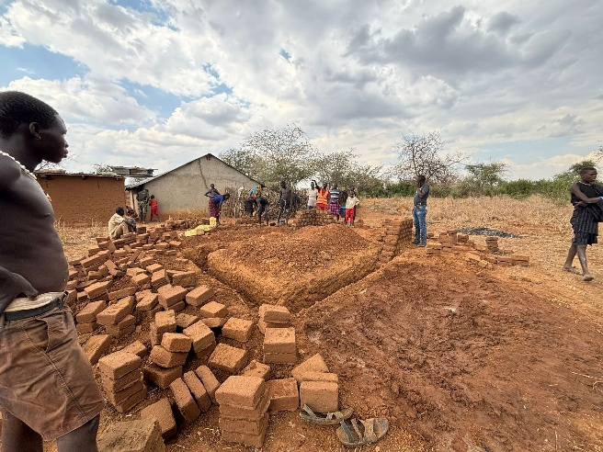 | 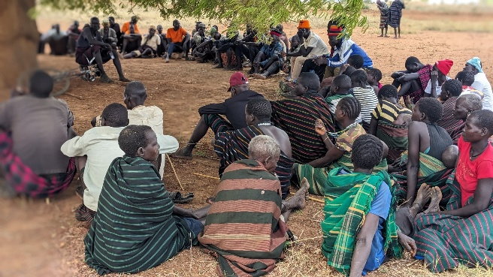
Digging of the foundation for the storage building of Ngikarachuna Ngulu ka Akicha Youth Group on the 21st/01/2025 - MOA | The meeting Natiir /Losakucha in Kapeta sub county gathered participants from different parishes of Kapeta on the 18th/03/2025 -MOA
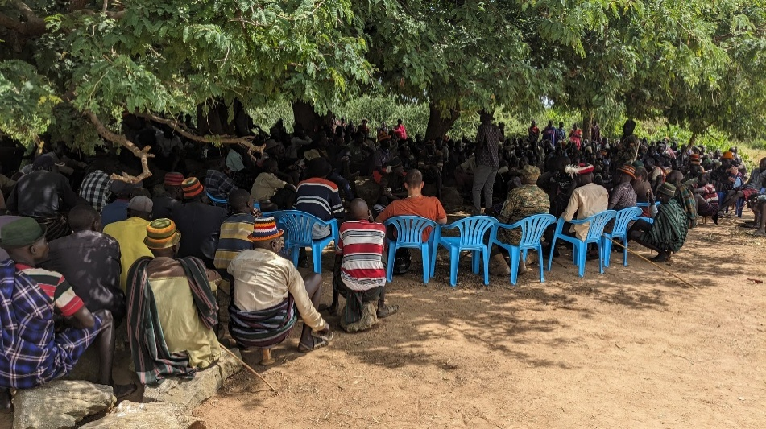 | 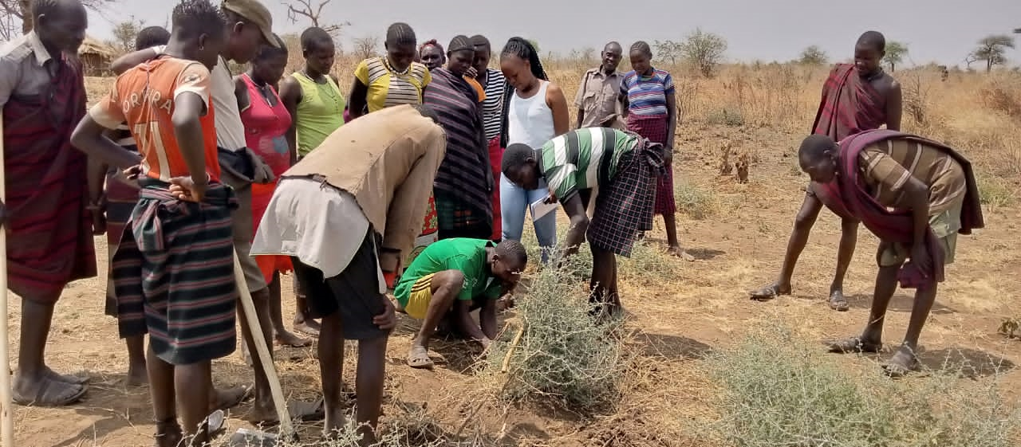
Participants in a Dialogue meeting held in Kanalobae on the 26th/06/2026 - Zivik | The PECs and SCECs of moruitit during a practical session on FMNR during a training conducted on the 25/2/2025 - GIZ
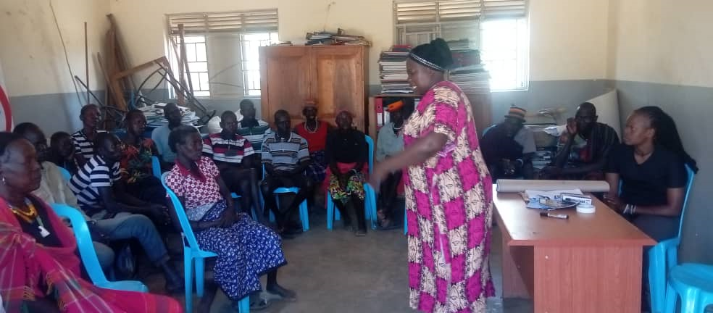 | 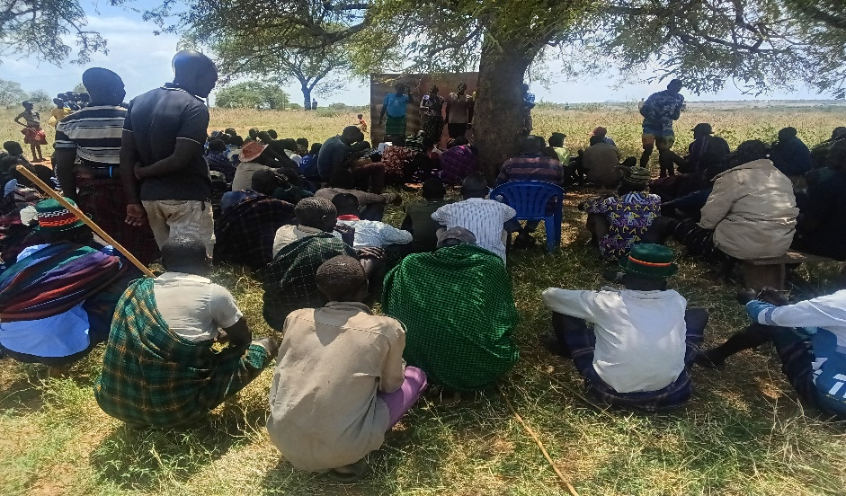
The PEC and SCEC members of Regen town board and Lokorein Parish during the training conducted on 27/2/2025. - GIZ | Awareness raising in Lochoto Parish on 14/03/2025 - DKA
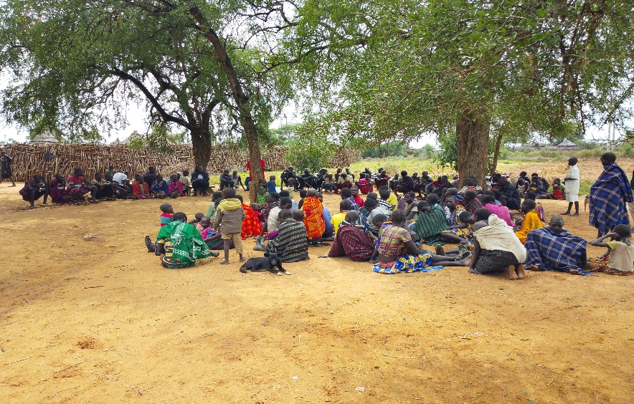 | 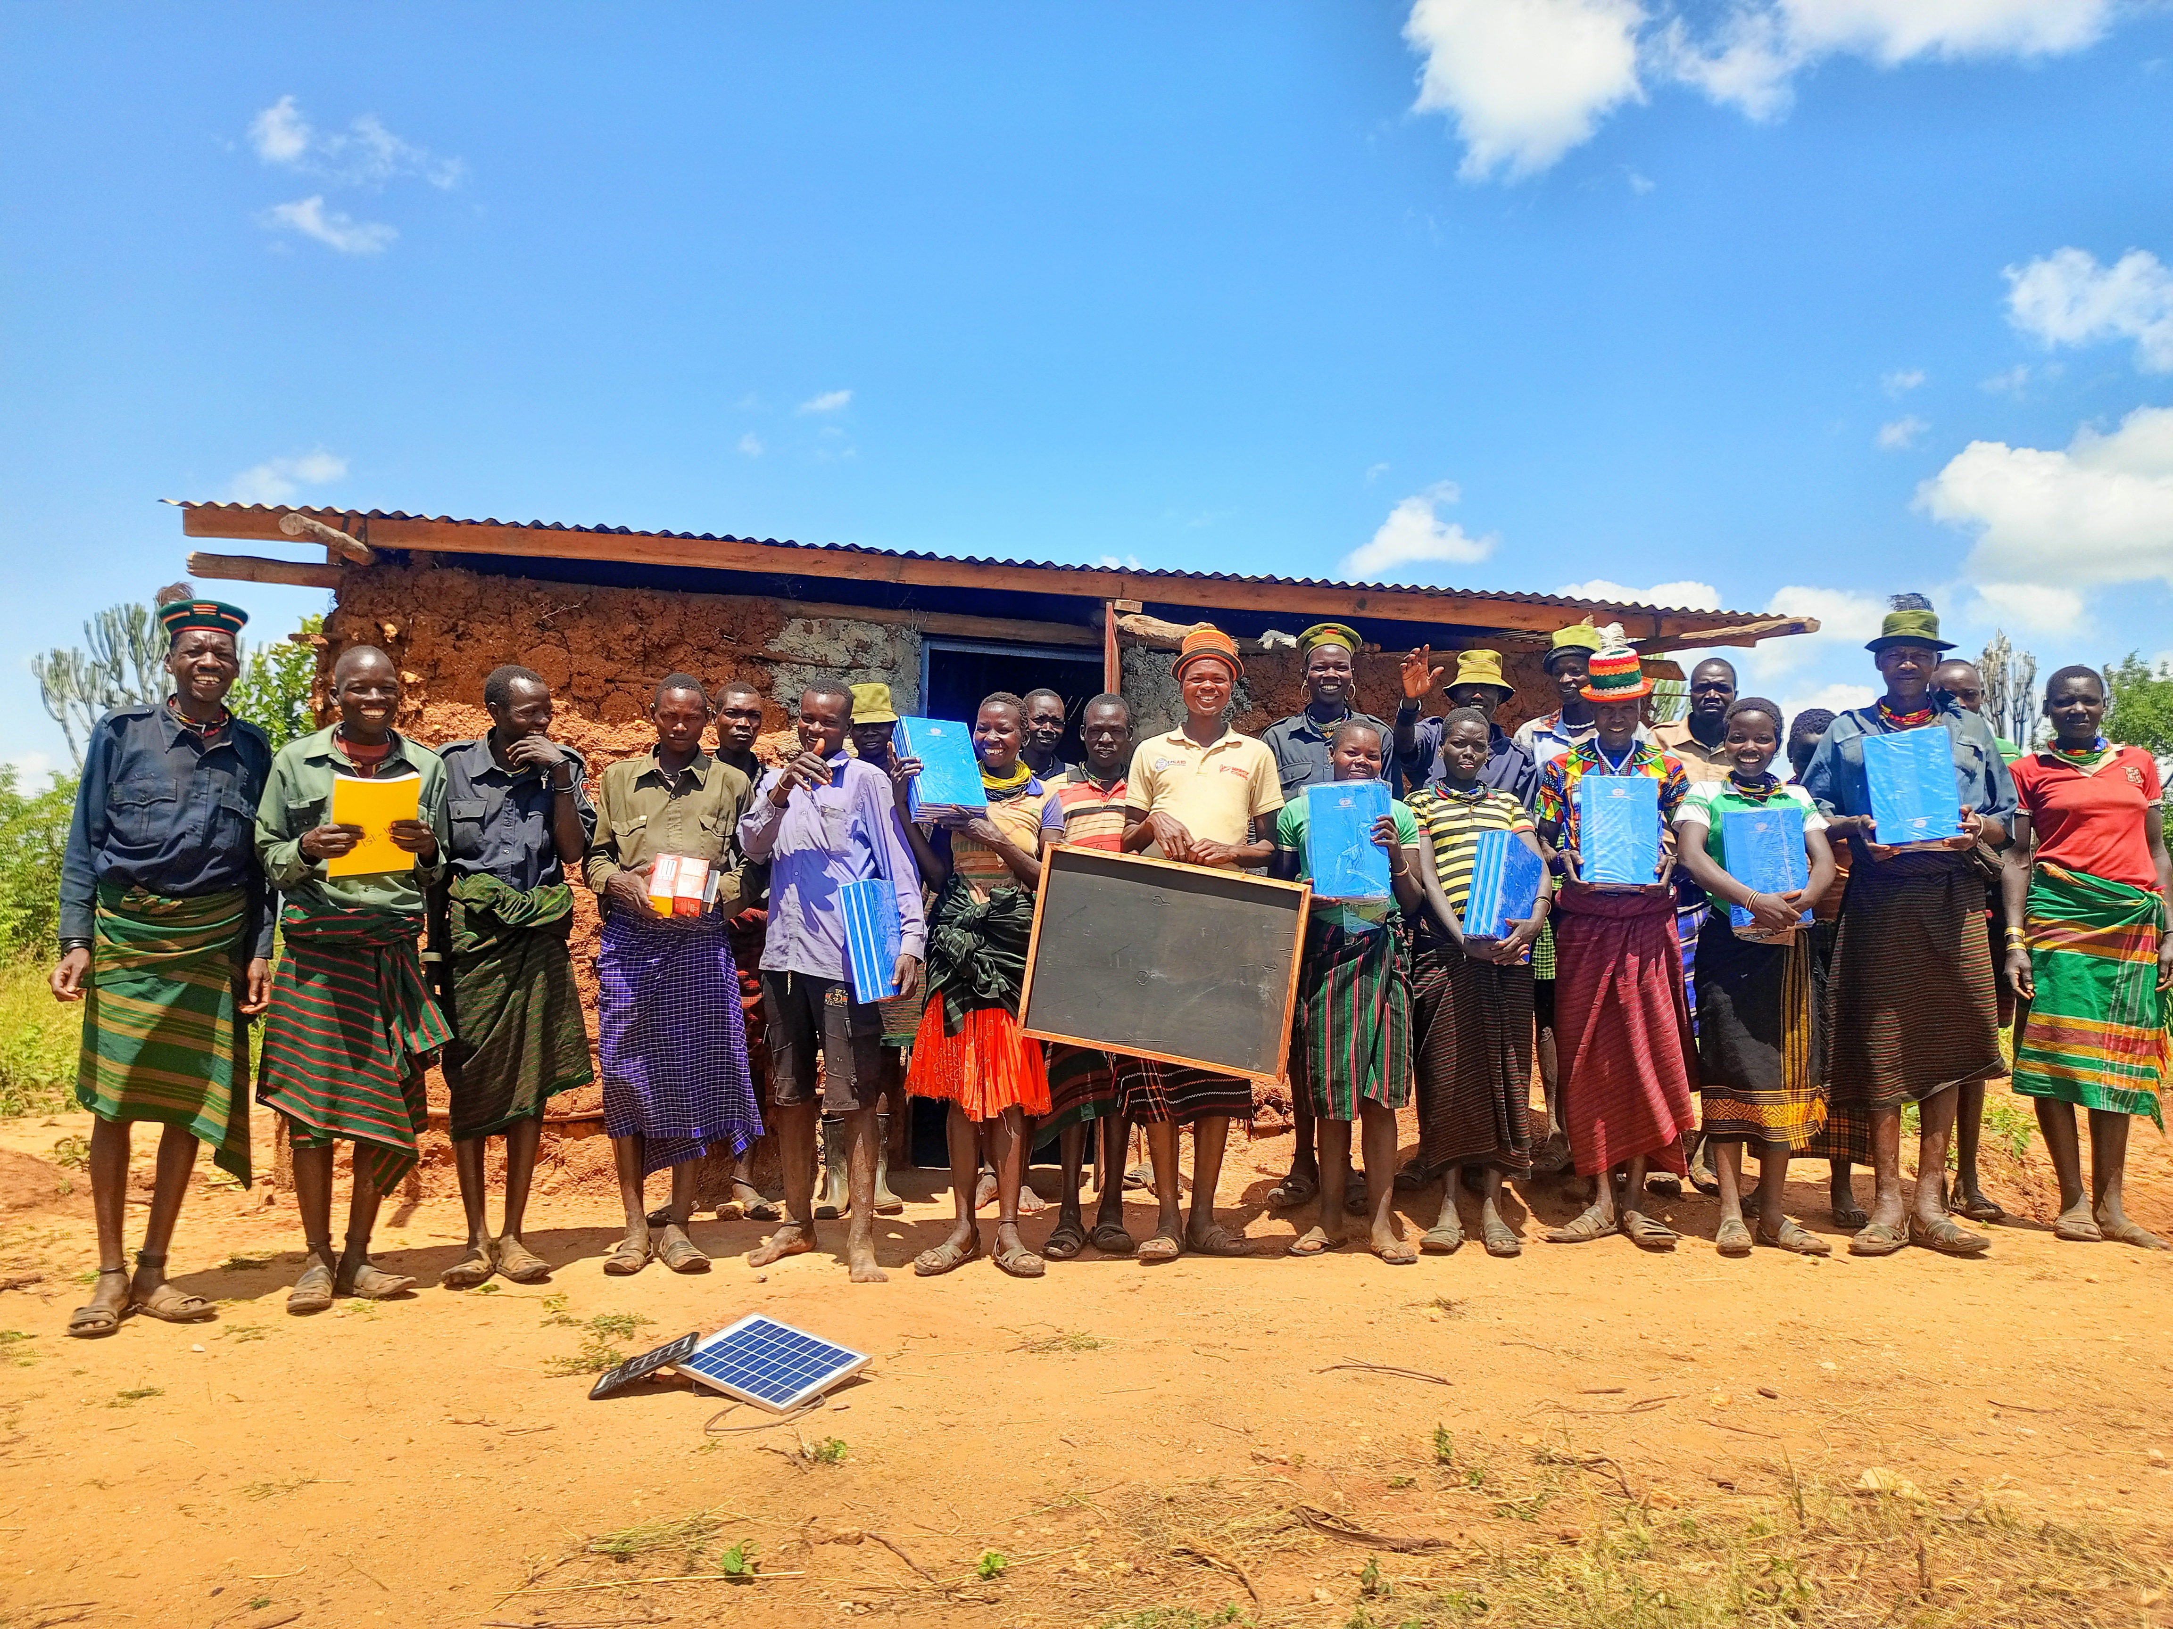
Community creation meeting in Logwangaita Parish on 19/06/2025 - GIZ | Lodwar Disarmed Youth farmers’ Group taking the pictorial after receiving the learning material for literacy and numercy classes on 25/06/2025 - Zivik
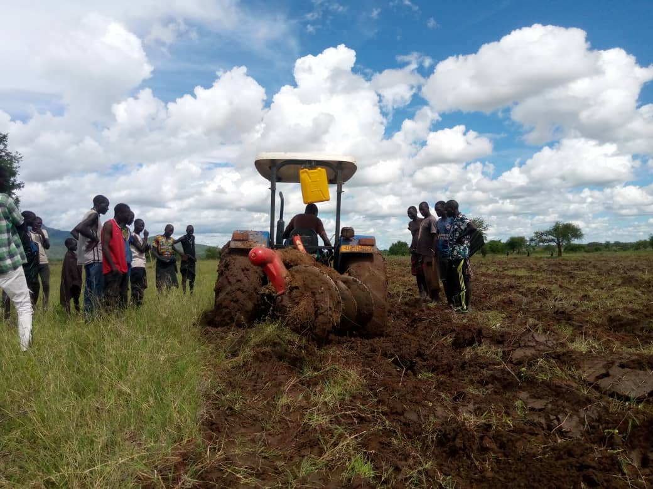 | 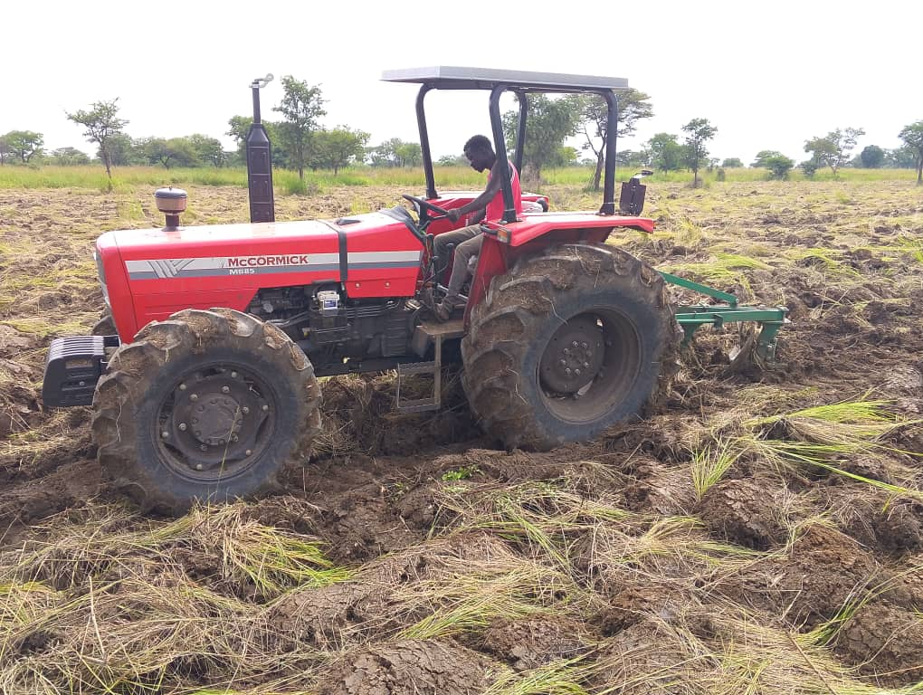
Ploughing of the Arengechoto Youth Group – MOA and Agiamondo Projects. | Tractor purchased through Prosolidar support ploughing a garden in Lobanya, June 2025– Prosolidar.

